**VISVESVARAYA TECHNOLOGICAL UNIVERSITY**

**“JnanaSangama”, Belgaum -590014, Karnataka.**



**LAB REPORT**

**on**

**Object Oriented Java Programming (23CS3PCOOJ)**

***Submitted by***

**Ayaan Shrestha (1BM23CS056)**

***in partial fulfillment for the award of the degree of***

**BACHELOR OF ENGINEERING**

***in***

**COMPUTER SCIENCE AND ENGINEERING**



**B.M.S. COLLEGE OF ENGINEERING**

**(Autonomous Institution under VTU)**

**BENGALURU-560019**

**Sep-2024 to Jan-2025**

**B.M.S. College of Engineering,**

**Bull Temple Road, Bangalore 560019**

(Affiliated To Visvesvaraya Technological University, Belgaum)

**Department of Computer Science and Engineering**



**CERTIFICATE**

This is to certify that the Lab work entitled “Object Oriented Java Programming (23CS3PCOOJ)” carried out by **Ayaan Shrestha (1BM23CS056),** who is a bonafide student of **B.M.S. College of Engineering.** It is in partial fulfillment for the award of **Bachelor of Engineering in Computer Science and Engineering** of the Visvesvaraya Technological University, Belgaum. The Lab report has been approved as it satisfies the academic requirements in respect of an Object Oriented Java Programming (23CS3PCOOJ) work prescribed for the said degree.

| Dr. Prasad Gr  Assistant Professor  Department of CSE, BMSCE | Dr. Jyothi S Nayak  Professor & HOD  Department of CSE, BMSCE |
| --- | --- |

**Index**

| **Sl.**  **No.** | **Date** | **Experiment Title** | **Page No.** |
| --- | --- | --- | --- |
| 1 | 9/10/24 | Implement Quadratic Equation | 4 |
| 2 | 16/10/24 | Implement SGPA Calculator | 9 |
| 3 | 23/10/24 | Create Objects for Books | 19 |
| 4 | 30/10/24 | Implement Abstract Class | 24 |
| 5 | 6/11/24 | Bank Account Management | 29 |
| 6 | 13/11/24 | Implement Packages | 41 |
| 7 | 20/11/24 | Implement Exception Handling | 54 |
| 8 | 27/11/24 | Multithreading, Creating Threads in Java | 59 |
| 9 | 27/11/24 | Interface to Perform Integer Division | 62 |
| 10 | 27/11/24 | Implement Deadlock  Implement Inter-process Communication | 67  72 |

Github Link:

<https://github.com/ayaanstha/JAVA>

**Program 1**

Implement Quadratic Equation

**Algorithm:**

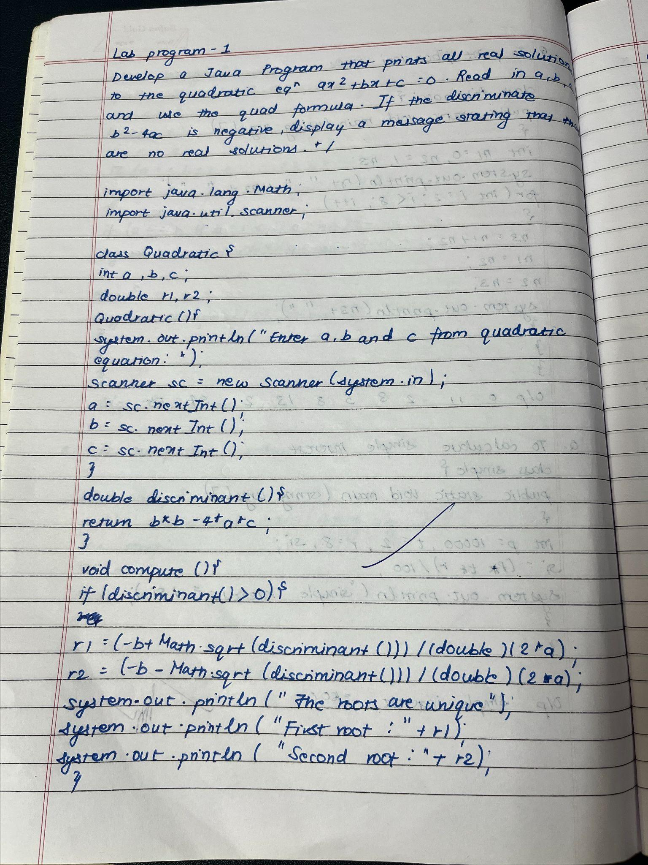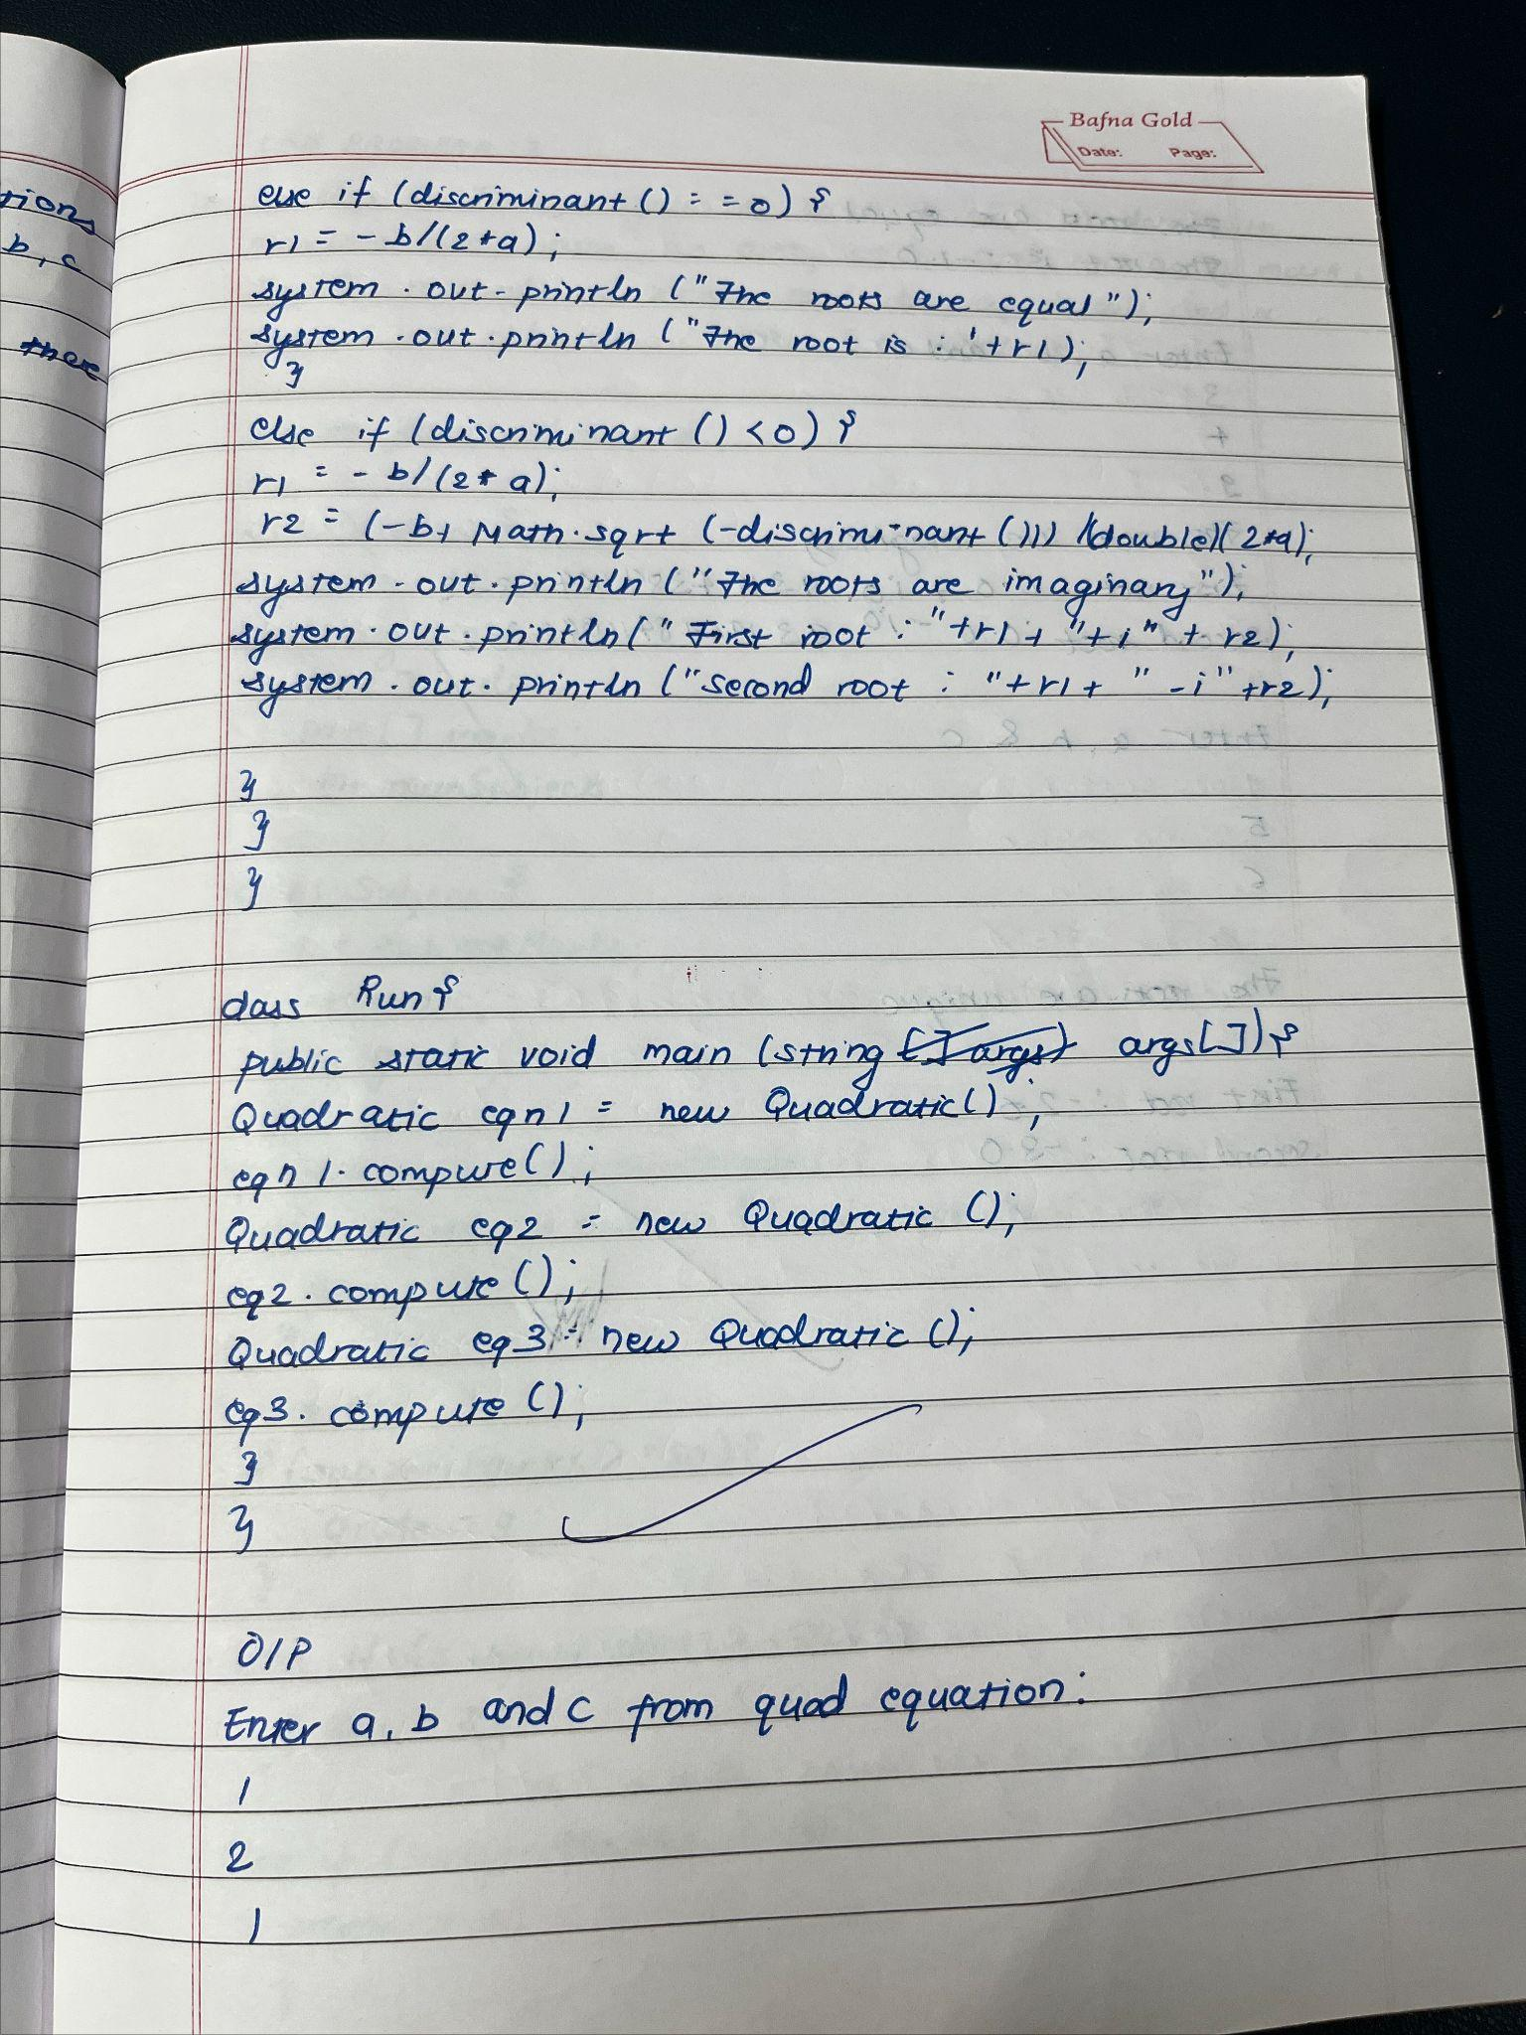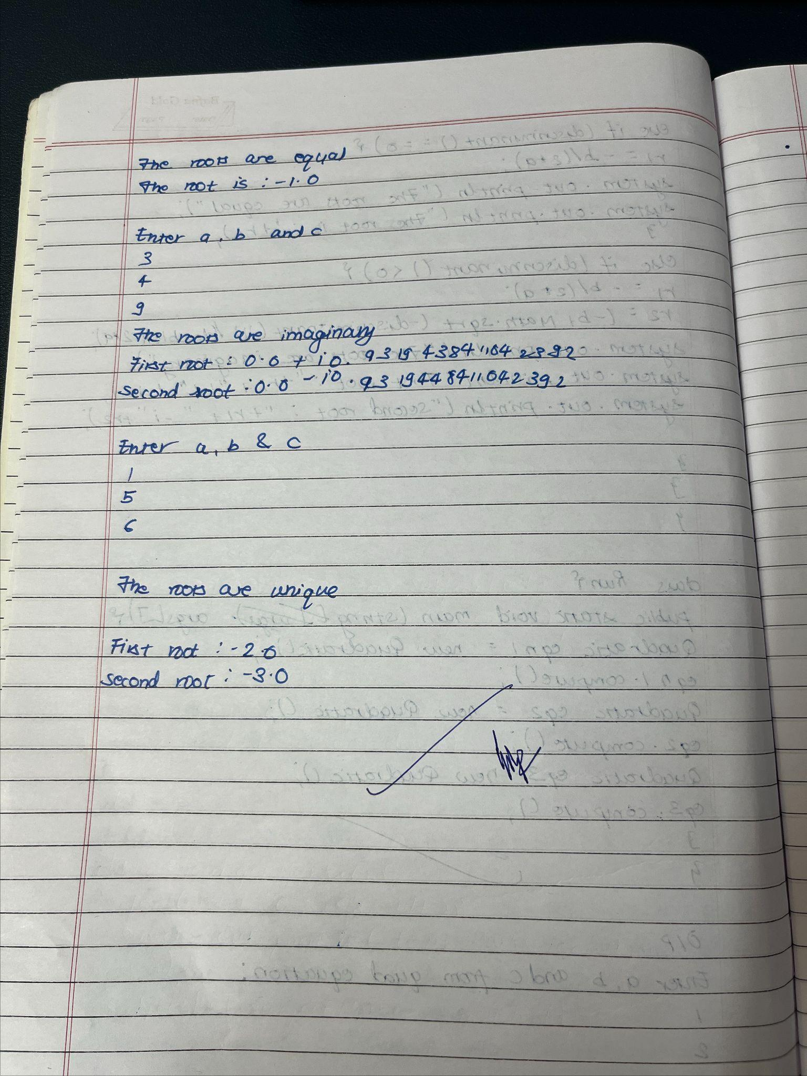

**Code:**

import java.util.Scanner;

public class Main {

public static void main(String[] args) {

Scanner scanner = new Scanner(System.in);

System.out.print("Enter coefficient a: ");

double a = scanner.nextDouble();

System.out.print("Enter coefficient b: ");

double b = scanner.nextDouble();

System.out.print("Enter coefficient c: ");

double c = scanner.nextDouble();

double discriminant = b * b - 4 * a * c;

if (discriminant > 0) {

double root1 = (-b + Math.sqrt(discriminant)) / (2 * a);

double root2 = (-b - Math.sqrt(discriminant)) / (2 * a);

System.out.println("The roots are real and different:");

System.out.println("Root 1: " + root1);

System.out.println("Root 2: " + root2);

} else if (discriminant == 0) {

double root = -b / (2 * a);

System.out.println("The roots are real and the same:");

System.out.println("Root: " + root);

} else {

System.out.println("The roots are complex:");

double realPart = -b / (2 * a);

double imaginaryPart = Math.sqrt(-discriminant) / (2 * a);

System.out.println("Root 1: " + realPart + " + " + imaginaryPart + "i");

System.out.println("Root 2: " + realPart + " - " + imaginaryPart + "i");

System.out.print("Ayaan Shrestha 1BM23CS056");

}

scanner.close();

}

}

Output :

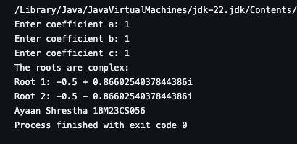

**Program 2 :**

**Implement SGPA Calculator**

**Algorithm :**

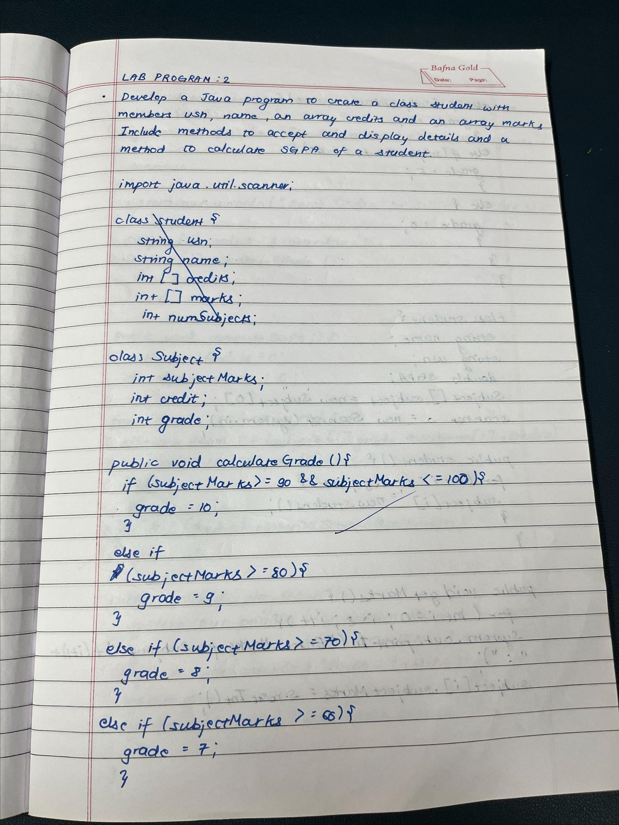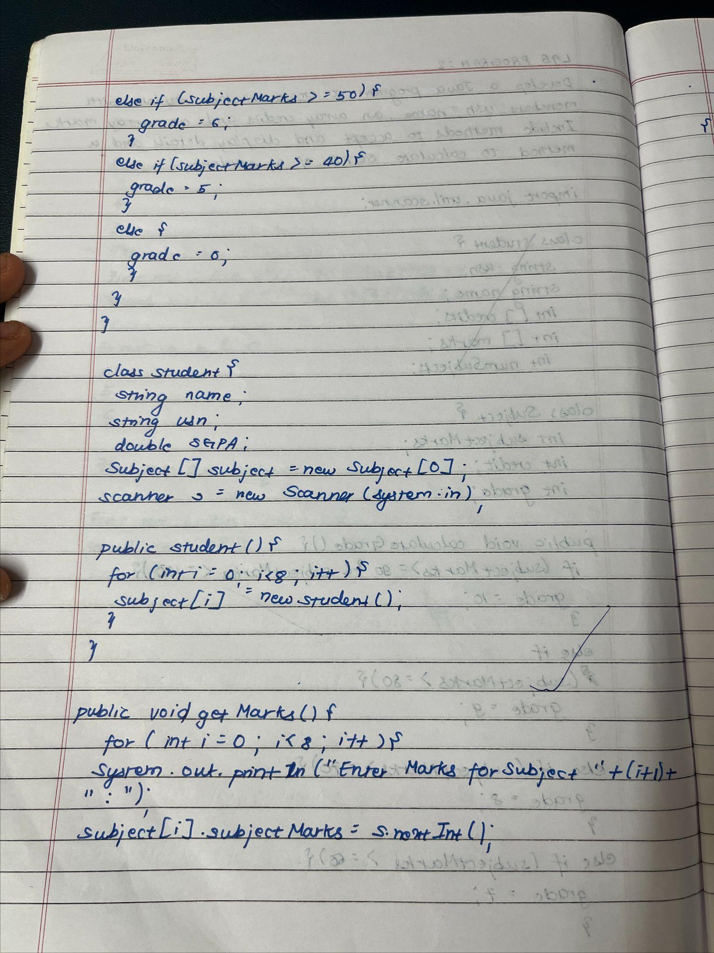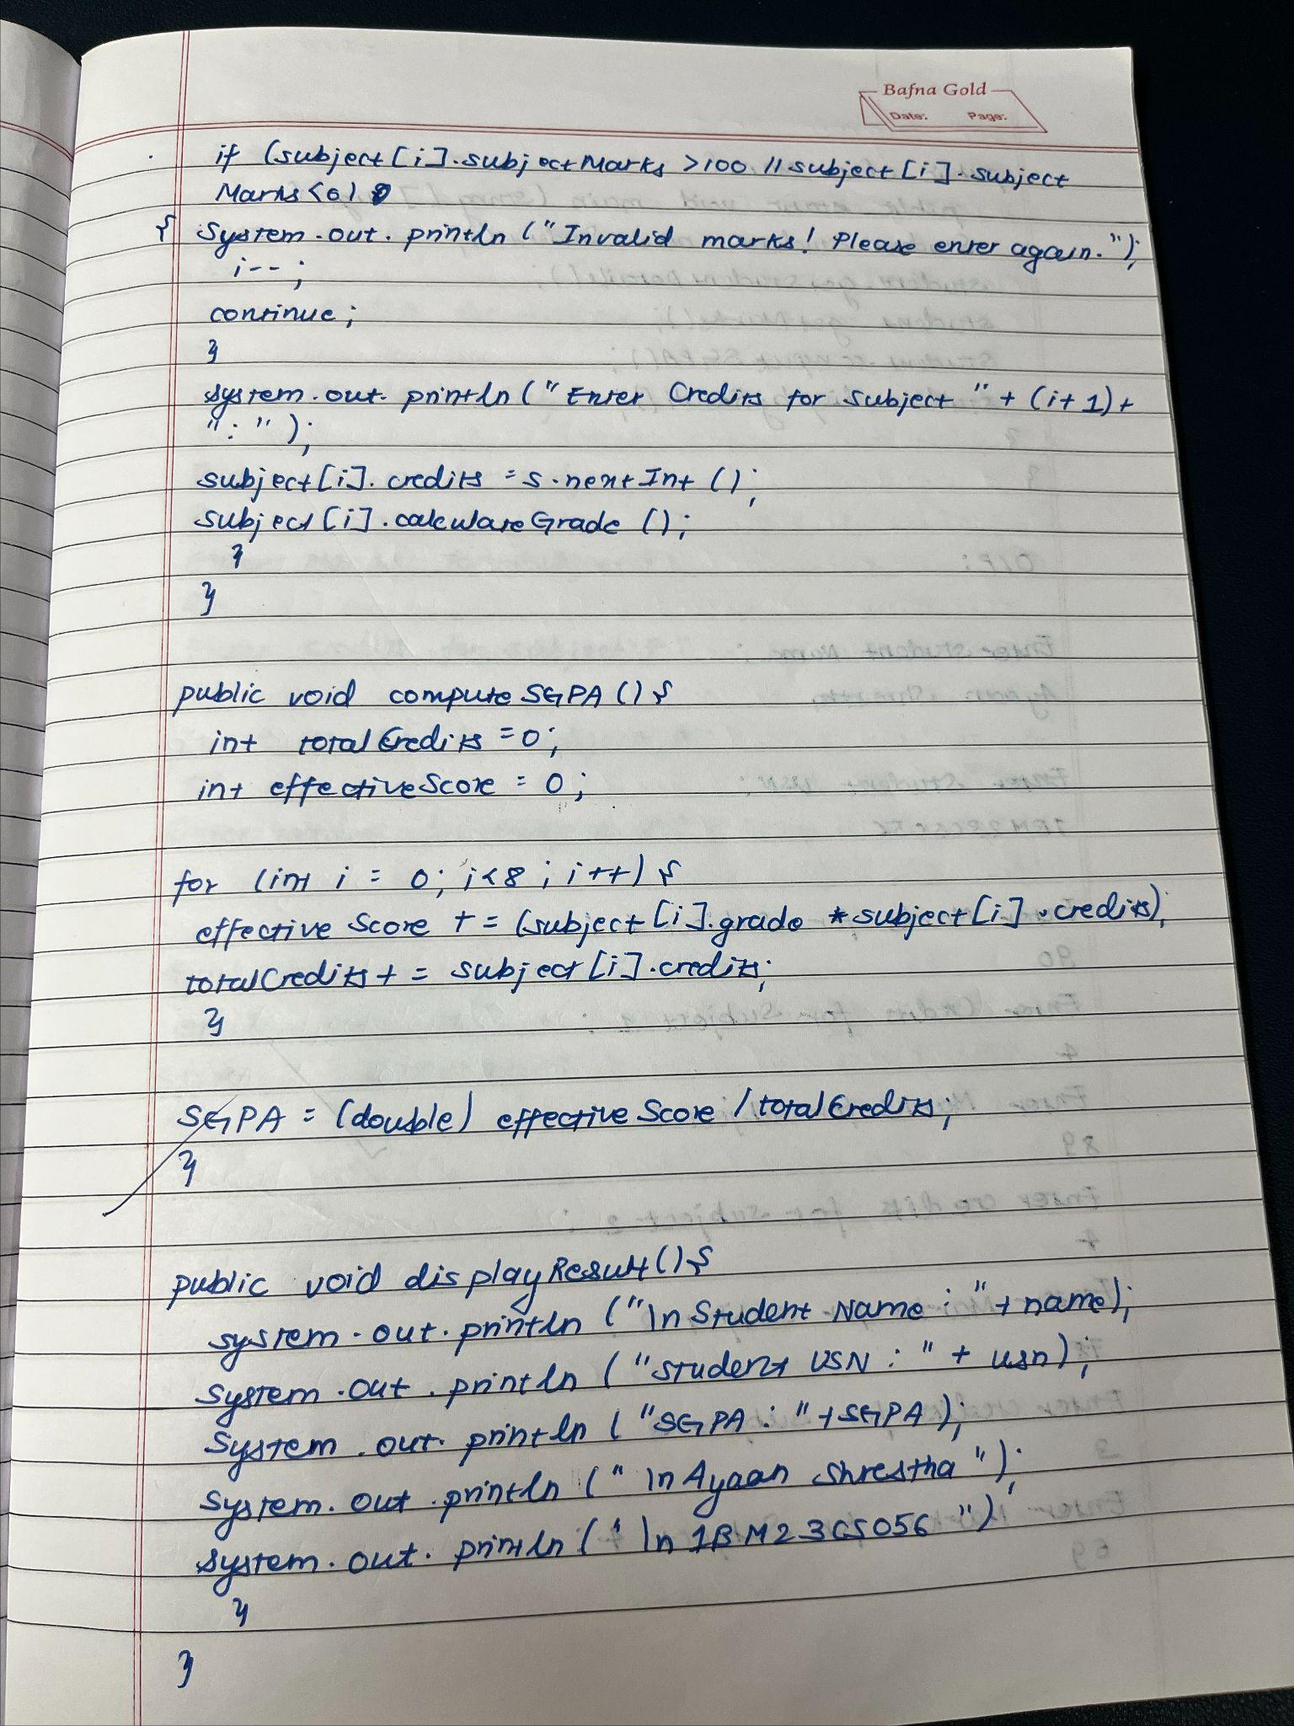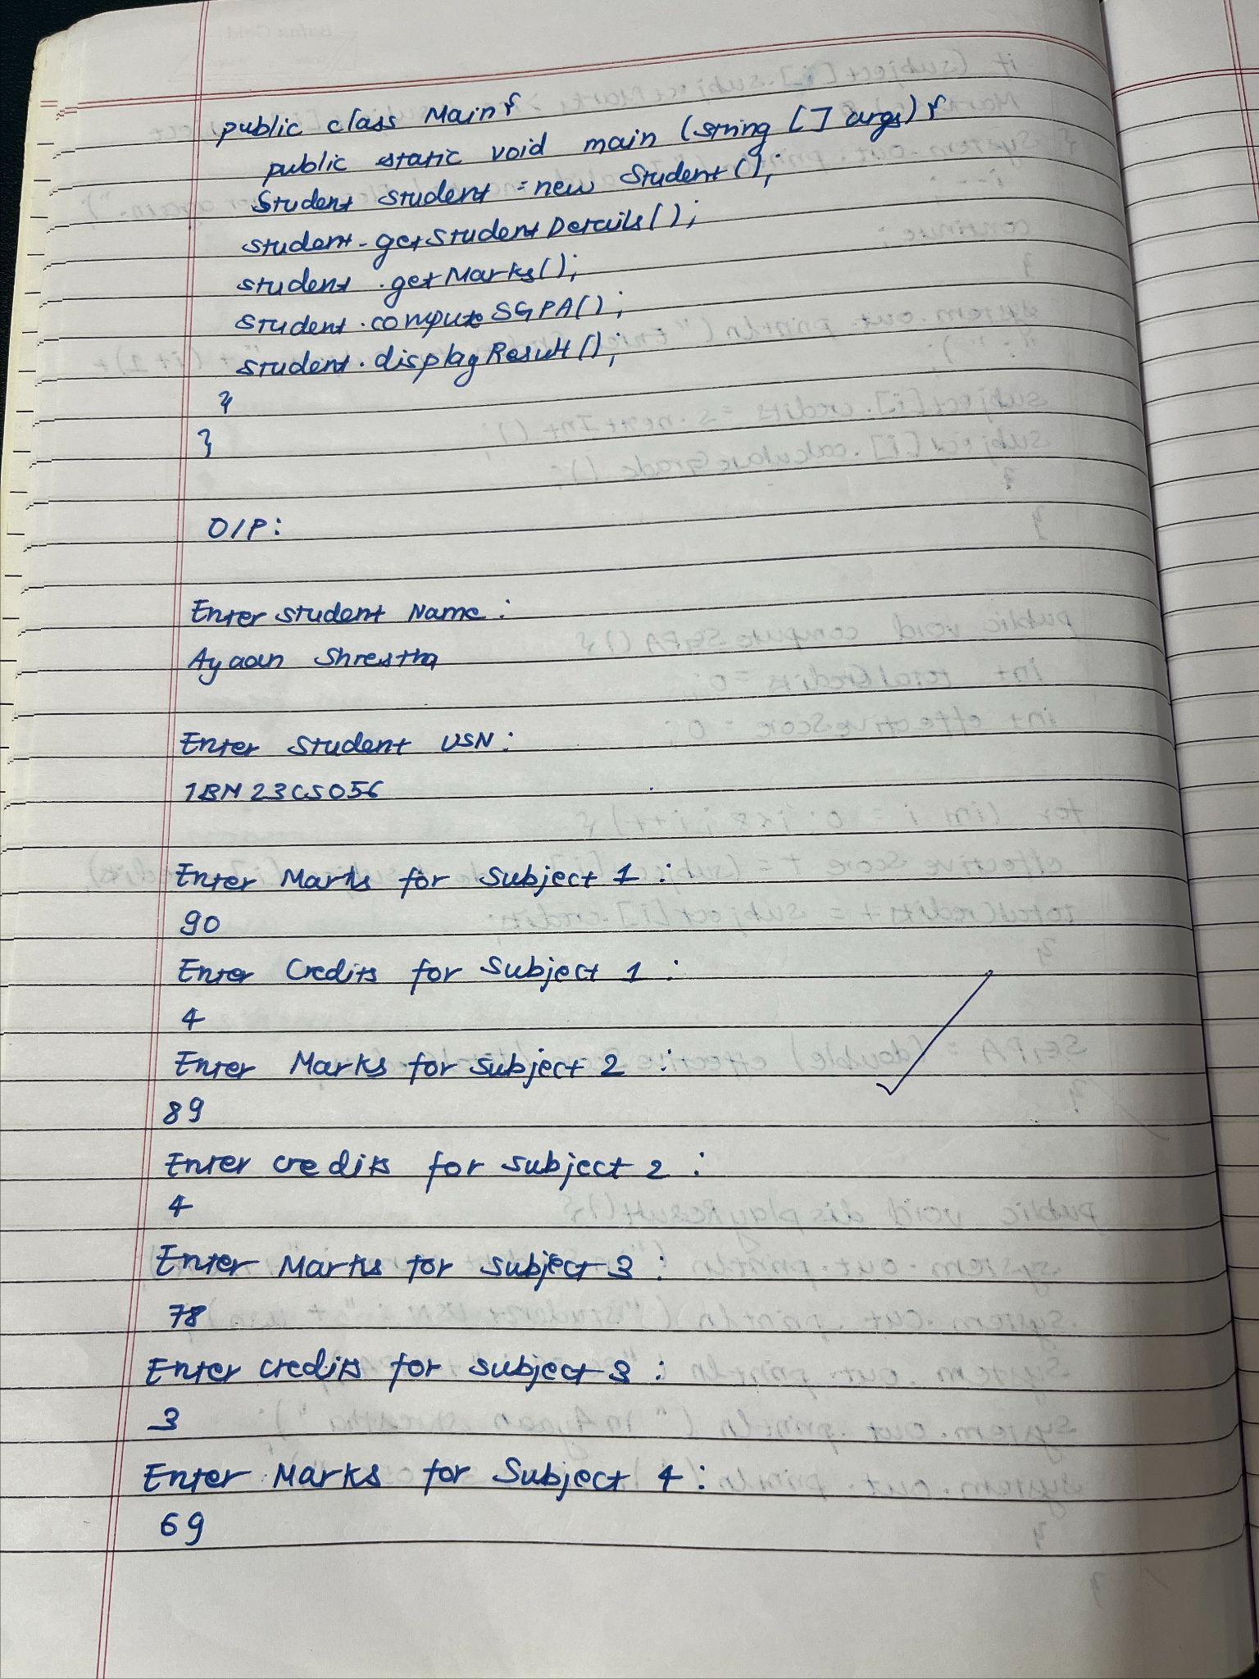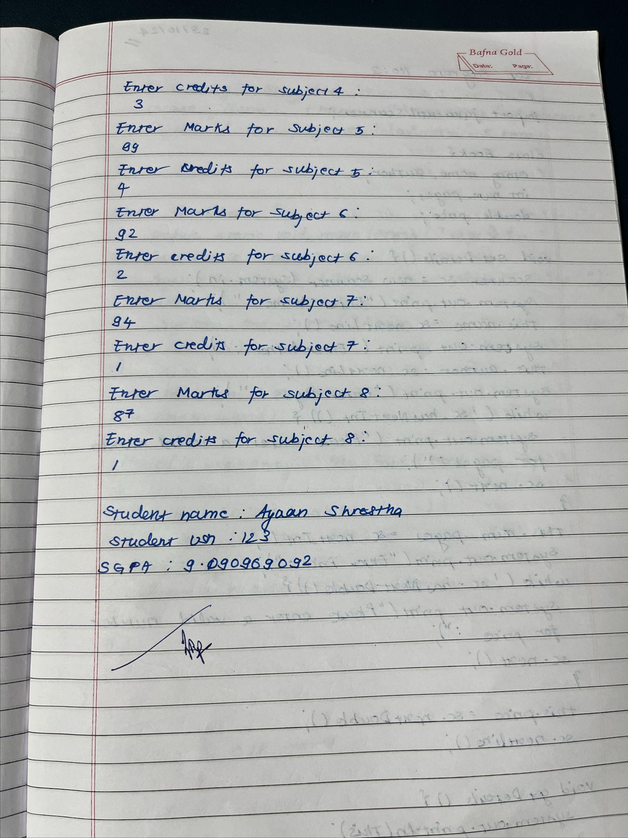

**Code :**

import java.util.Scanner;

class Subject {

int subjectMarks;

int credits;

int grade;

// Method to calculate grade based on marks

public void calculateGrade() {

if (subjectMarks >= 90 && subjectMarks <= 100) {

grade = 10;

} else if (subjectMarks >= 80) {

grade = 9;

} else if (subjectMarks >= 70) {

grade = 8;

} else if (subjectMarks >= 60) {

grade = 7;

} else if (subjectMarks >= 50) {

grade = 6;

} else if (subjectMarks >= 40) {

grade = 5;

} else {

grade = 0; // Failed the subject

}

}

}

class Student {

String name;

String usn;

double SGPA;

Subject[] subject = new Subject[8];

Scanner s = new Scanner(System.in);

public Student() {

for (int i = 0; i < 8; i++) {

subject[i] = new Subject(); // Create subject objects

}

}

public void getStudentDetails() {

System.out.println("Enter Student Name: ");

name = s.nextLine();

System.out.println("Enter Student USN: ");

usn = s.nextLine();

}

public void getMarks() {

for (int i = 0; i < 8; i++) {

System.out.println("Enter Marks for Subject " + (i + 1) + ": ");

subject[i].subjectMarks = s.nextInt();

if (subject[i].subjectMarks > 100 || subject[i].subjectMarks < 0) {

System.out.println("Invalid marks! Please enter again.");

i--;

continue;

}

System.out.println("Enter Credits for Subject " + (i + 1) + ": ");

subject[i].credits = s.nextInt();

subject[i].calculateGrade(); // Calculate grade based on marks

}

}

public void computeSGPA() {

int totalCredits = 0;

int effectiveScore = 0;

for (int i = 0; i < 8; i++) {

effectiveScore += (subject[i].grade * subject[i].credits);

totalCredits += subject[i].credits;

}

SGPA = (double) effectiveScore / totalCredits;

}

public void displayResult() {

System.out.println("\nStudent Name: " + name);

System.out.println("Student USN: " + usn);

System.out.println("SGPA: " + SGPA);

}

}

public class Main {

public static void main(String[] args) {

Scanner s = new Scanner(System.in);

System.out.println("\nayaan shrestha");

Student[] students = new Student[3];

for (int i = 0; i < 3; i++) {

System.out.println("\nEnter details for Student " + (i + 1) + ": ");

students[i] = new Student(); // Create a new student object

students[i].getStudentDetails(); // Get name and usn

students[i].getMarks(); // Get marks and credits for subjects

students[i].computeSGPA(); // Compute SGPA

}

System.out.println("\n\nResults for all students:");

for (int i = 0; i < 3; i++) {

students[i].displayResult();

}

}

}

Output :

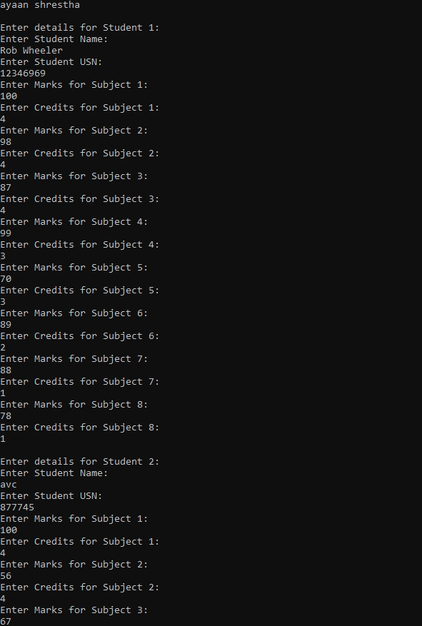

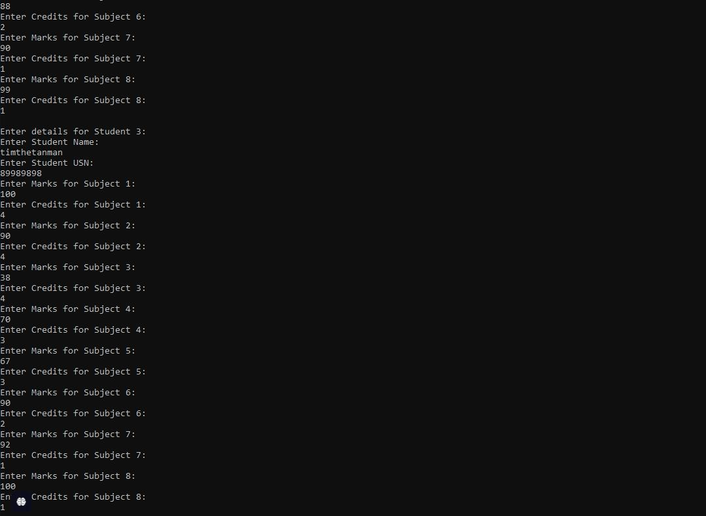

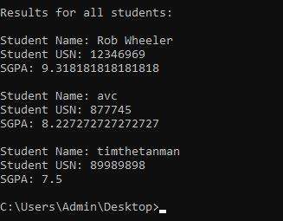

Program 3 :

Create Objects for Books

Algorithm:

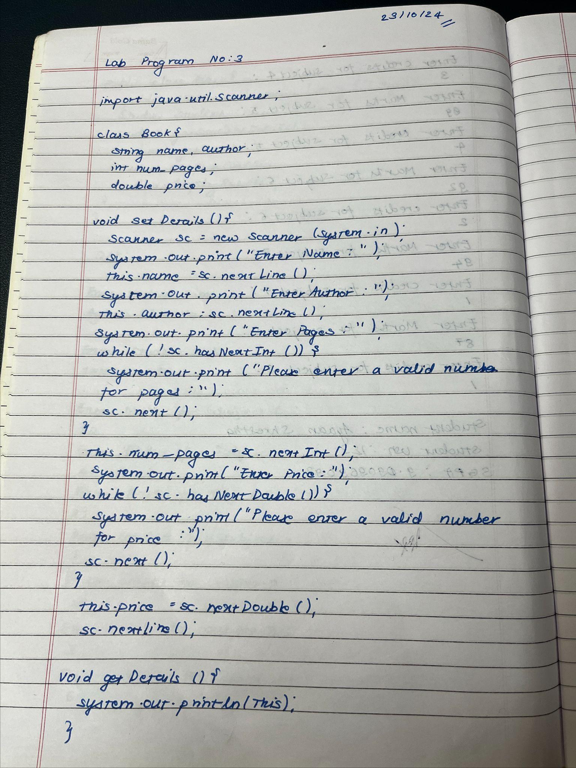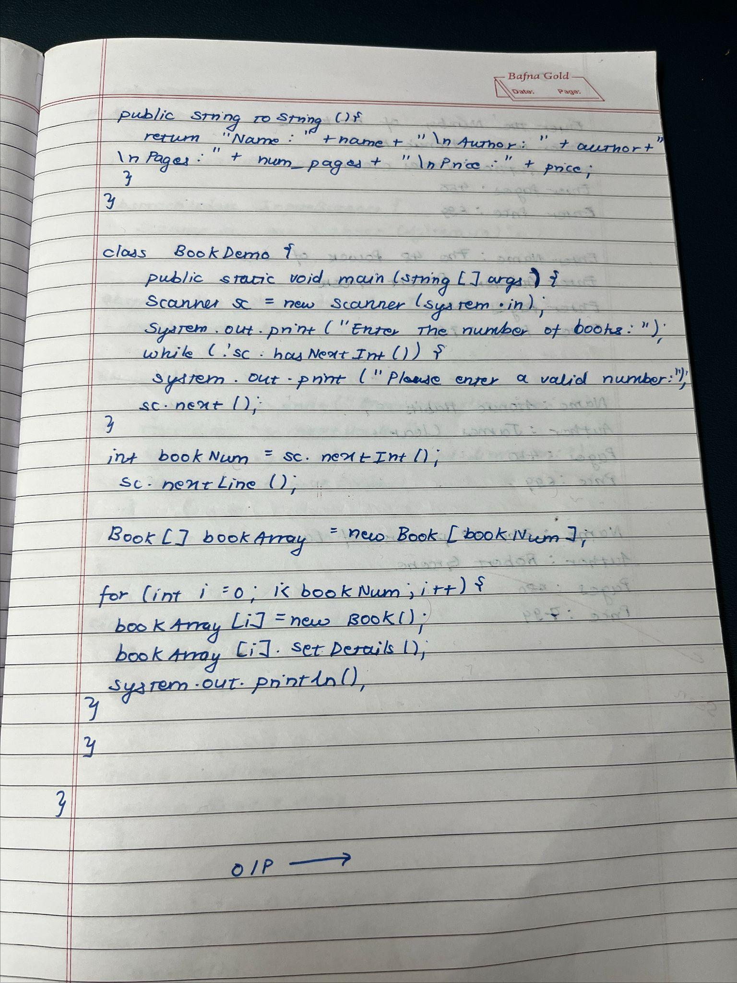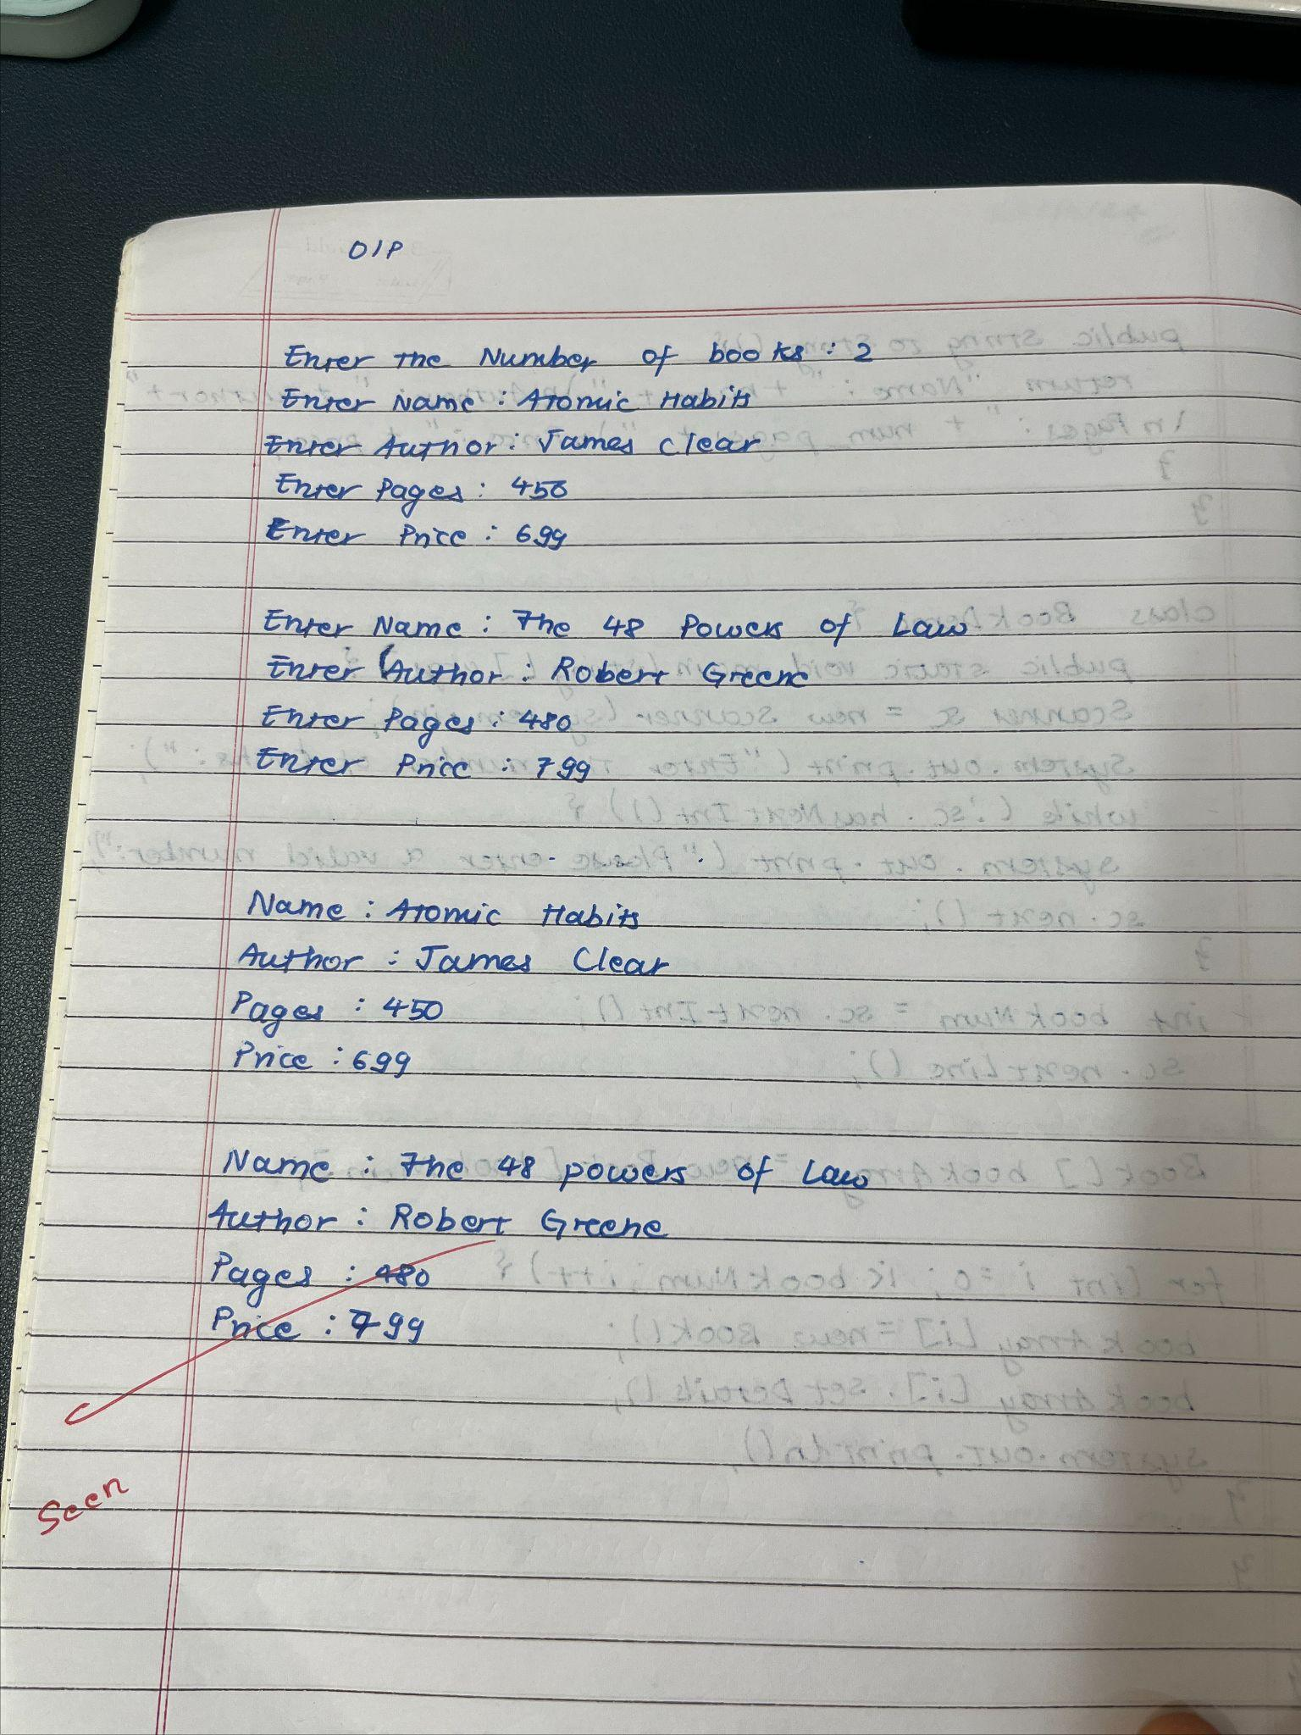

Code :

import java.util.Scanner;

class Book {

String name, author;

int num_pages;

double price;

void setDetails() {

Scanner sc = new Scanner(System.in);

System.out.print("Enter Name: ");

this.name = sc.nextLine();

System.out.print("Enter Author: ");

this.author = sc.nextLine();

System.out.print("Enter Pages: ");

while (!sc.hasNextInt()) {

System.out.print("Please enter a valid number for pages: ");

sc.next();

}

this.num_pages = sc.nextInt();

System.out.print("Enter Price: ");

while (!sc.hasNextDouble()) {

System.out.print("Please enter a valid number for price: ");

sc.next();

}

this.price = sc.nextDouble();

sc.nextLine(); }

void getDetails() {

System.out.println(this);

}

public String toString() {

return "Name: " + name + "\nAuthor: " + author + "\nPages: " + num_pages + "\nPrice: " + price;

}

}

class BookDemo {

public static void main(String[] args) {

Scanner sc = new Scanner(System.in);

System.out.print("Enter the number of books: ");

while (!sc.hasNextInt()) {

System.out.print("Please enter a valid number: ");

sc.next();

}

int bookNum = sc.nextInt();

sc.nextLine();

Book[] bookArray = new Book[bookNum];

for (int i = 0; i < bookNum; i++) {

bookArray[i] = new Book();

bookArray[i].setDetails();

System.out.println();

}

for (int i = 0; i < bookNum; i++) {

bookArray[i].getDetails();

System.out.println();

System.out.println("AYAAN SHRESTHA, 1BM23CS056");

}

}

}

Output:

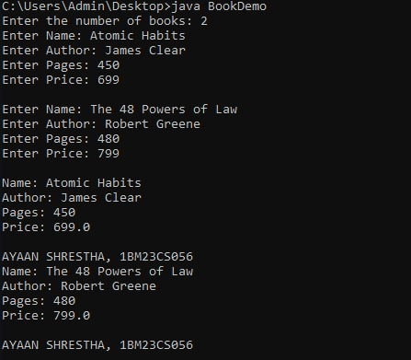

Program 4 : Implement Abstract Class

Algorithm:

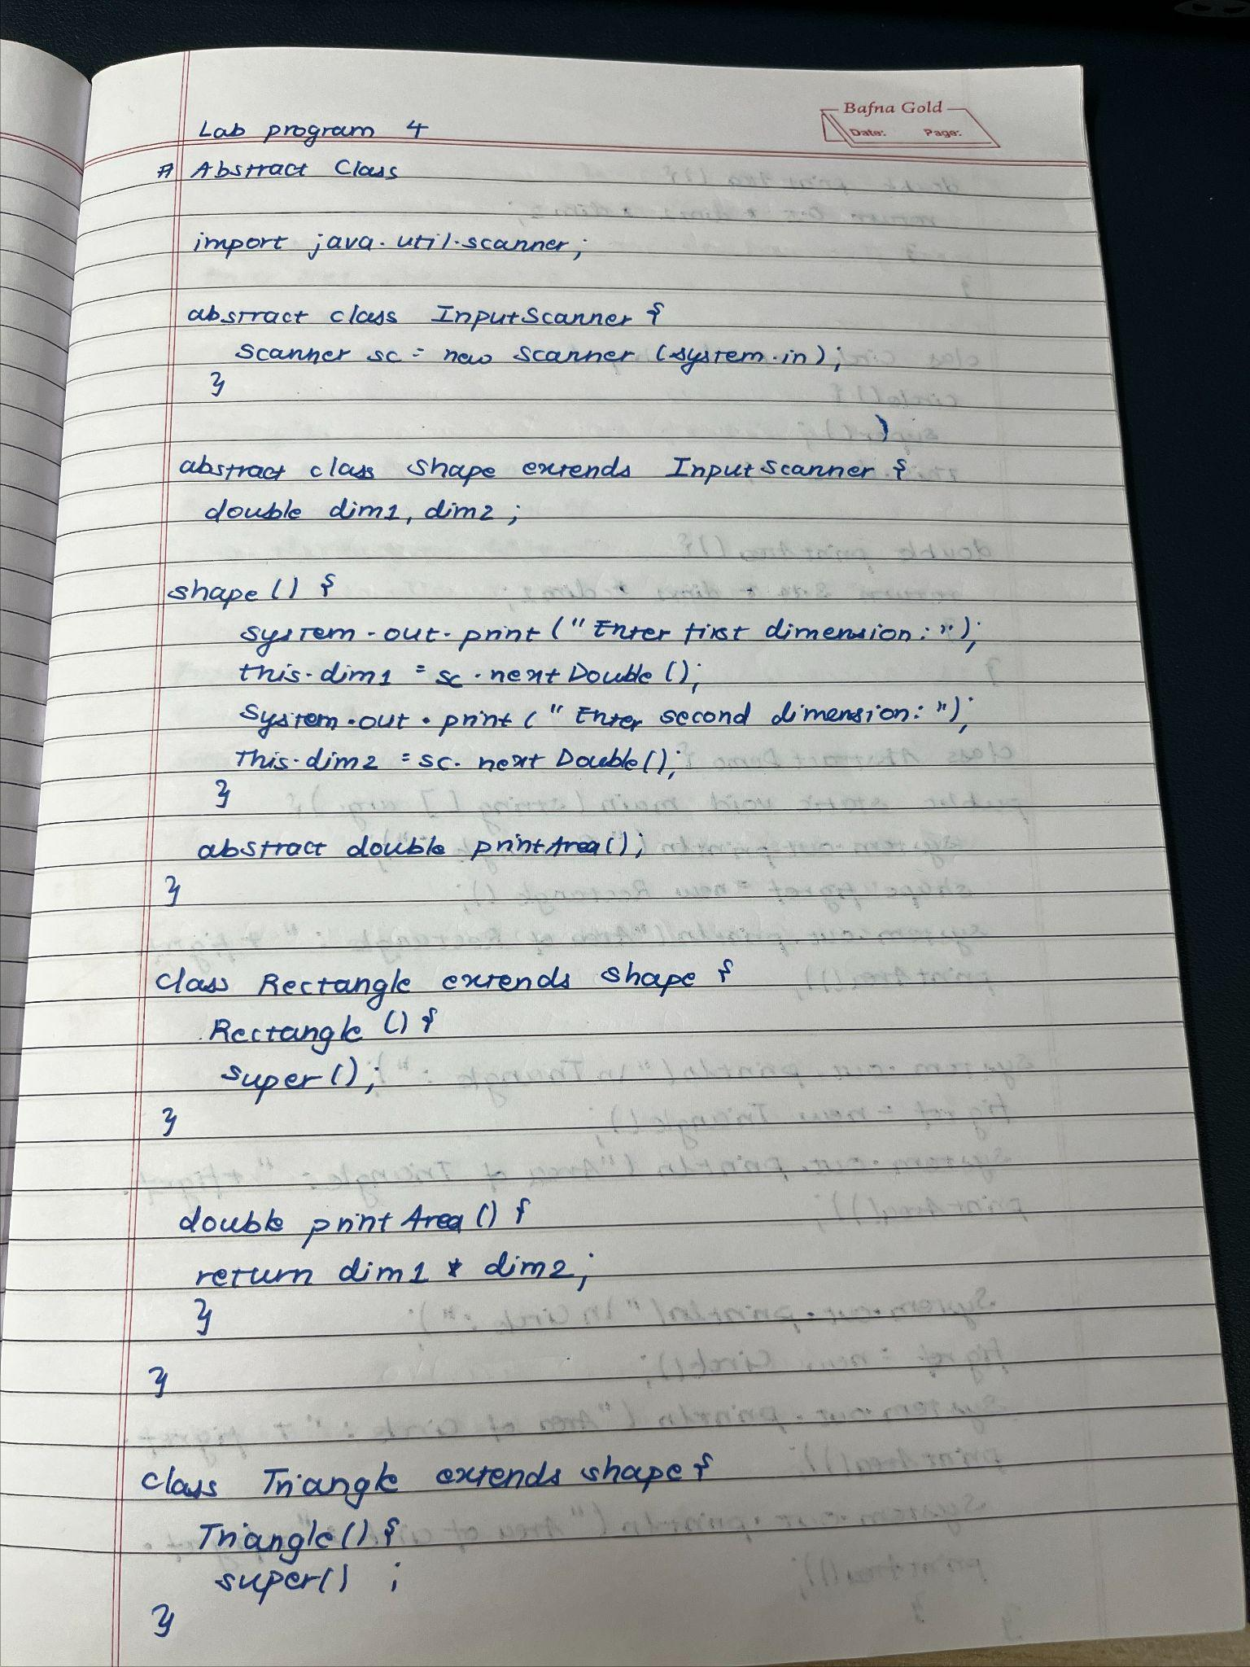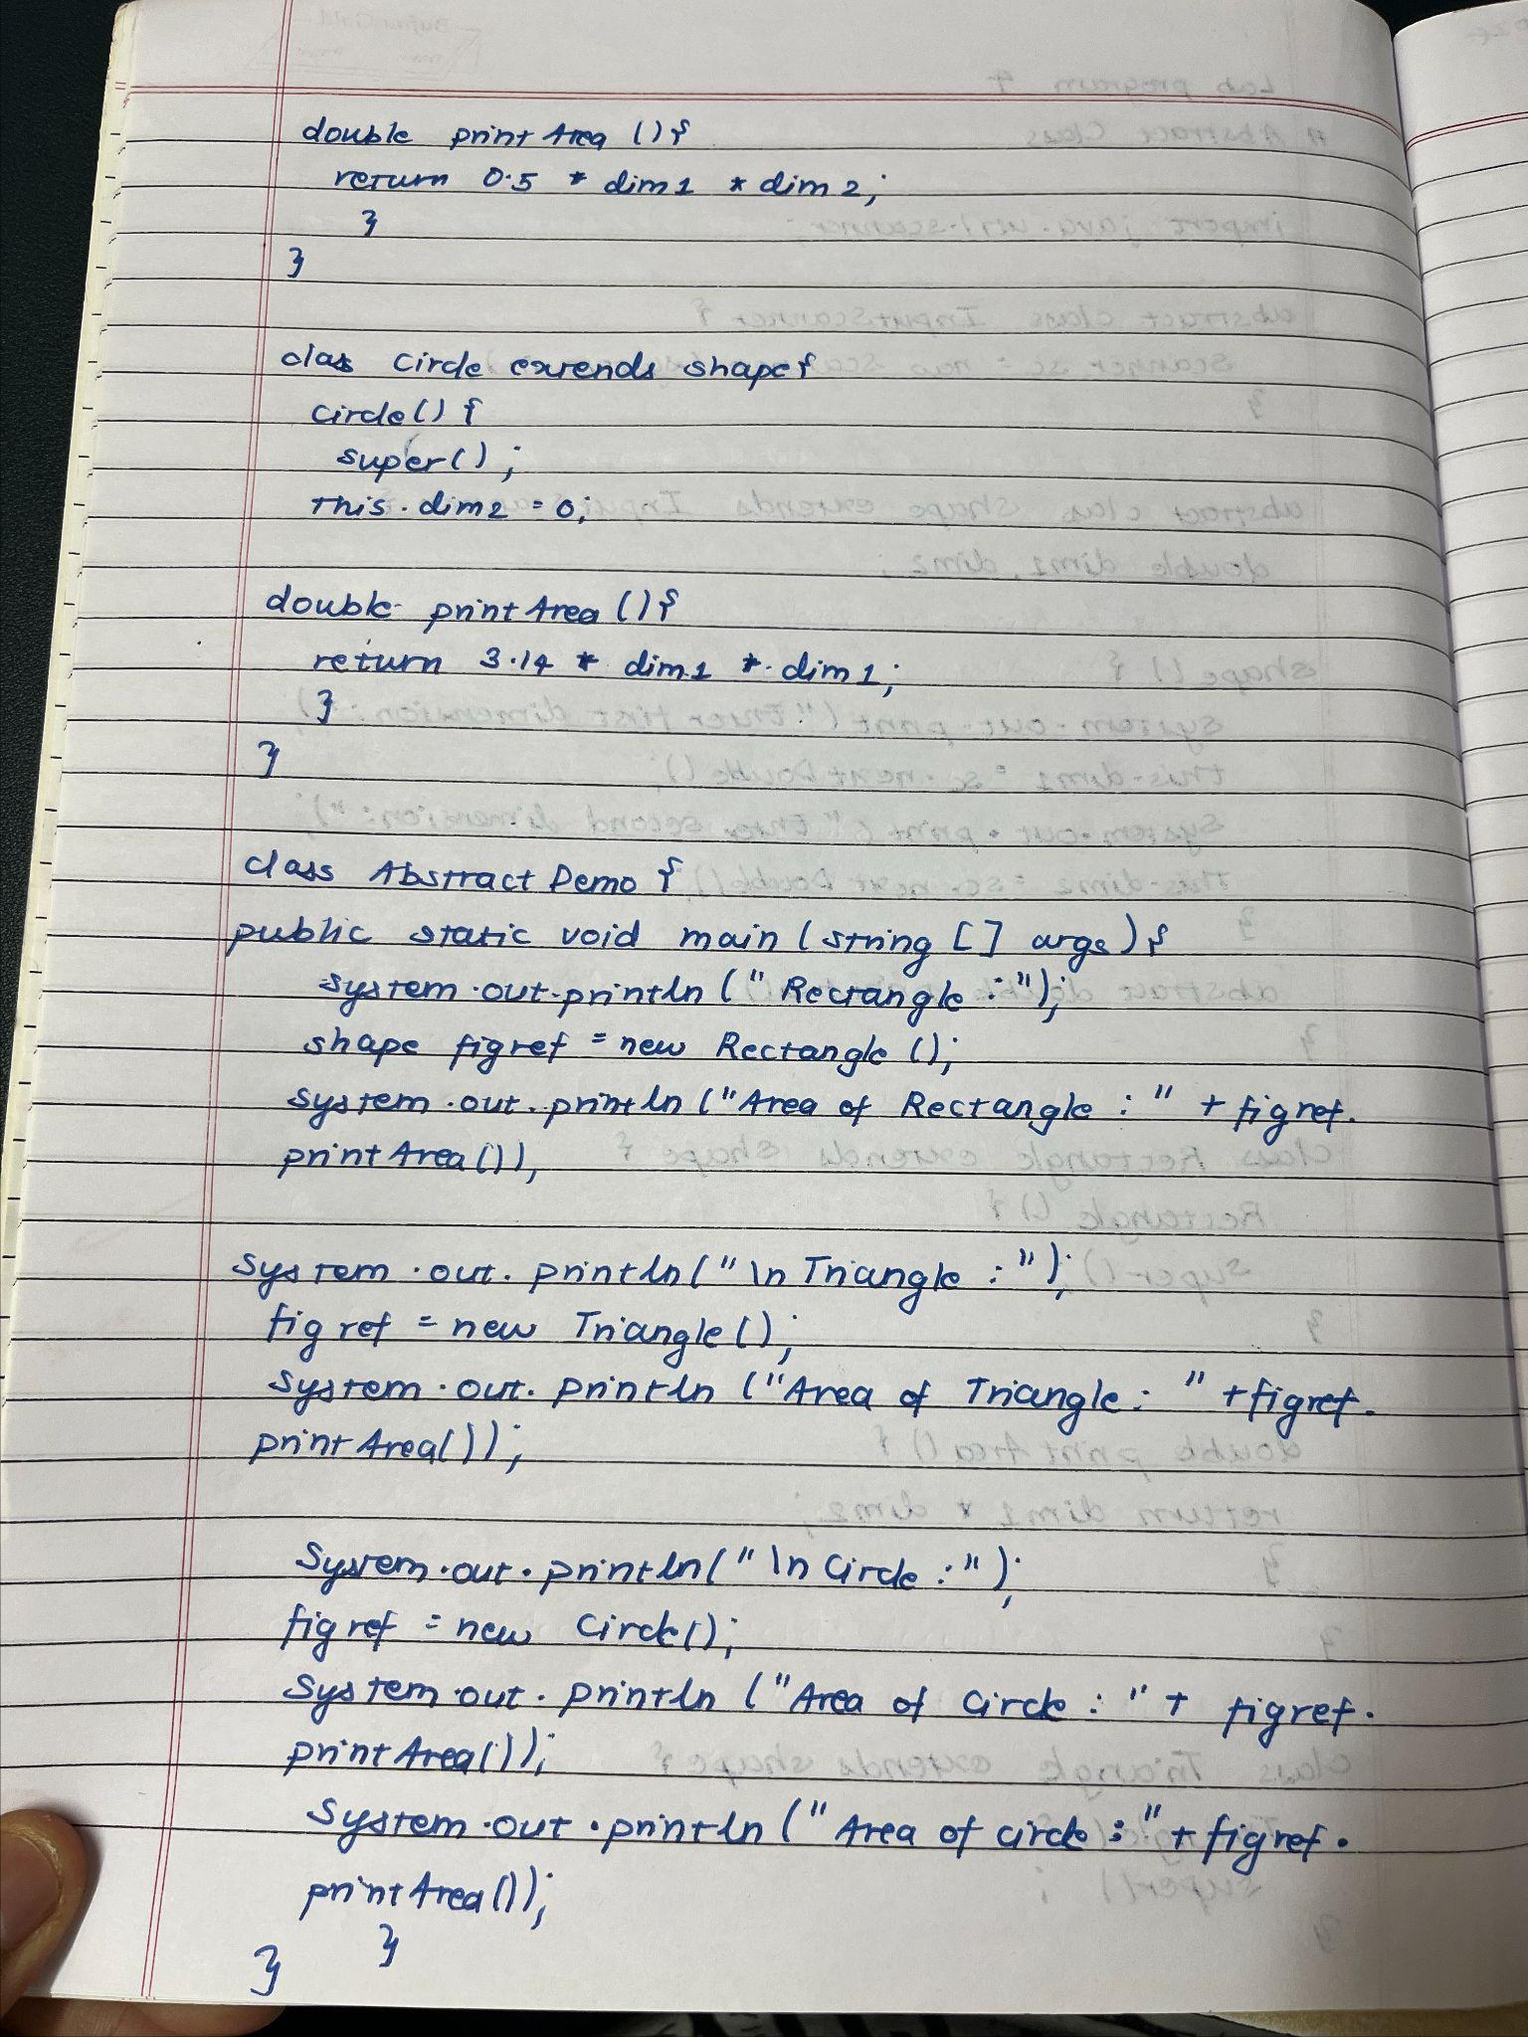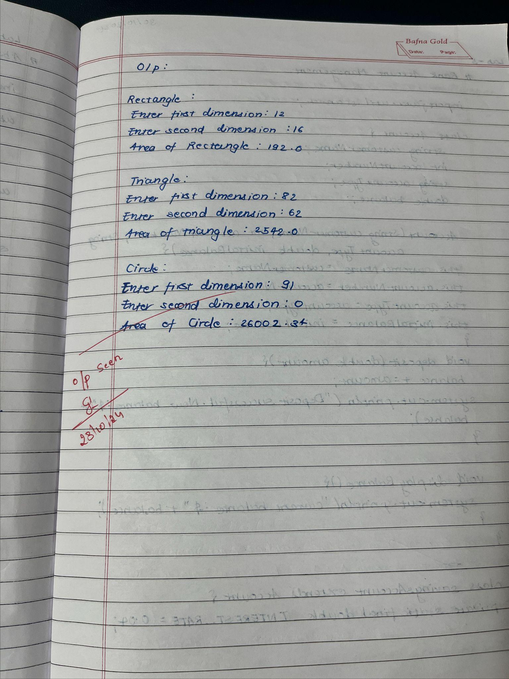

Code :

import java.util.Scanner;

abstract class InputScanner {

Scanner sc = new Scanner(System.in);

}

abstract class Shape extends InputScanner {

double dim1, dim2;

Shape() {

System.out.print("Enter first dimension: ");

this.dim1 = sc.nextDouble();

System.out.print("Enter second dimension: ");

this.dim2 = sc.nextDouble();

}

abstract double printArea();

}

class Rectangle extends Shape {

Rectangle() {

super();

}

double printArea() {

return dim1 * dim2;

}

}

class Triangle extends Shape {

Triangle() {

super();

}

double printArea() {

return 0.5 * dim1 * dim2;

}

}

class Circle extends Shape {

Circle() {

super();

this.dim2 = 0; }

double printArea() {

return 3.14 * dim1 * dim1;

}

}

class AbstractDemo {

public static void main(String[] args) {

System.out.println("Rectangle:");

Shape figref = new Rectangle();

System.out.println("Area of Rectangle: " + figref.printArea());

System.out.println("\nTriangle:");

figref = new Triangle();

System.out.println("Area of Triangle: " + figref.printArea());

System.out.println("\nCircle:");

figref = new Circle();

System.out.println("Area of Circle: " + figref.printArea());

System.out.println("AYAAN SHRESTHA, 1BM23CS056");

}

}

Output:

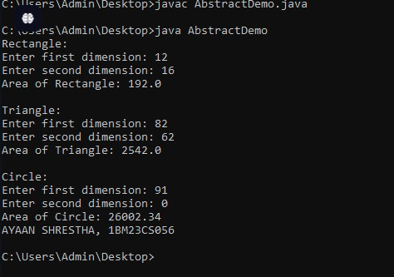

Program 5 : Bank Account Management

Algorithm :

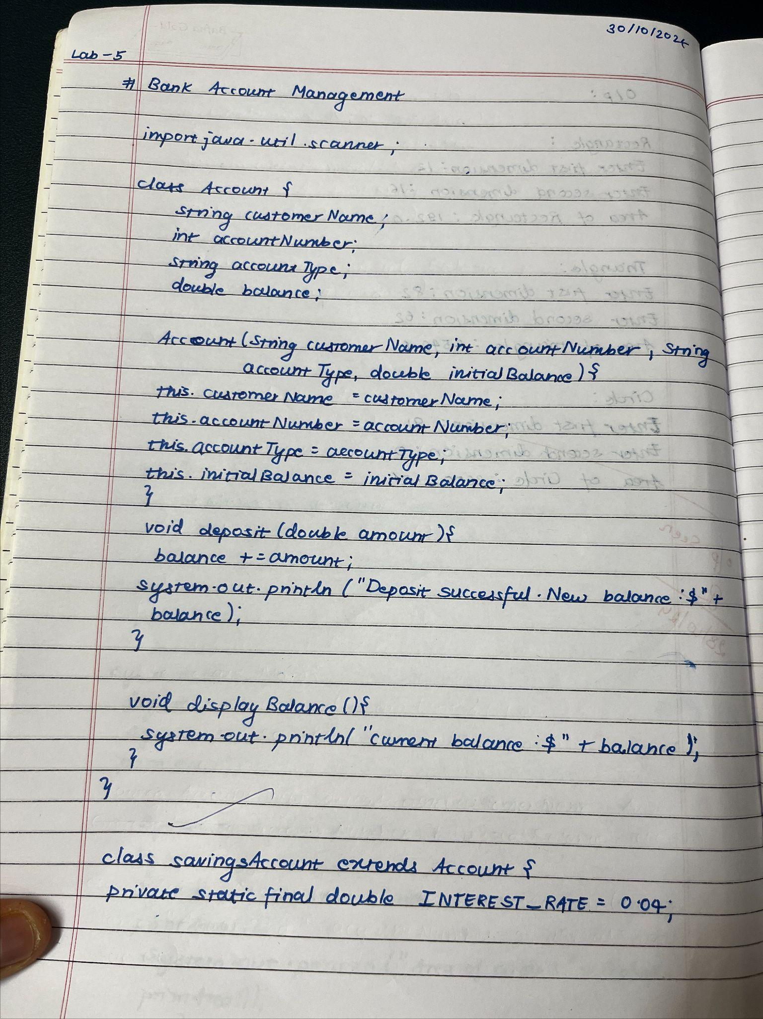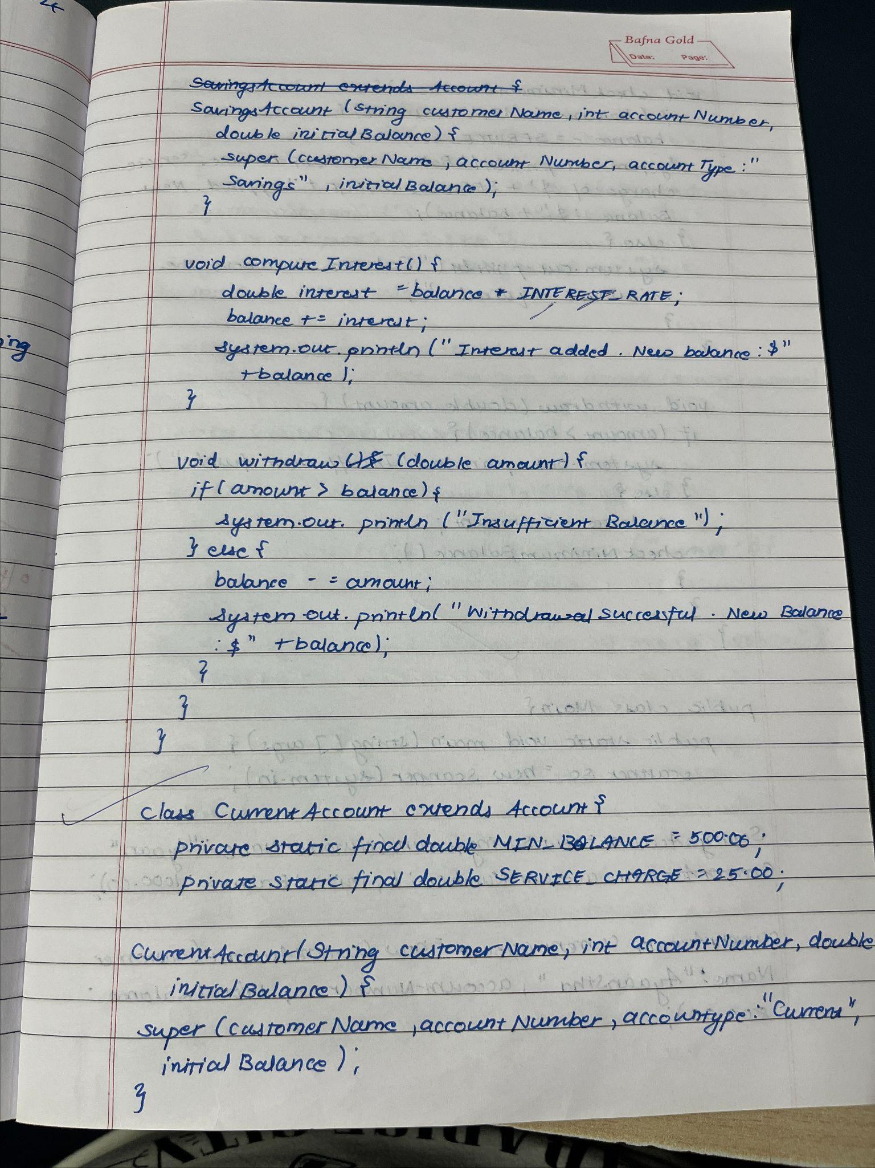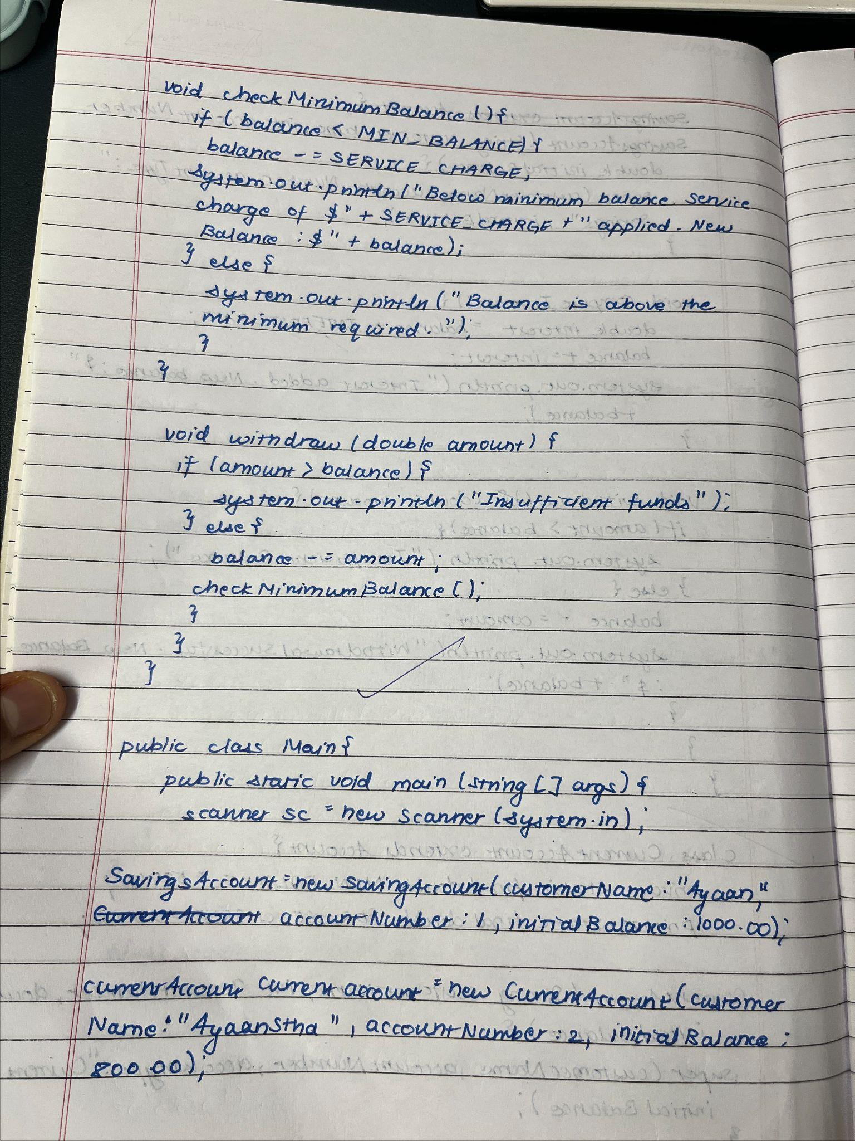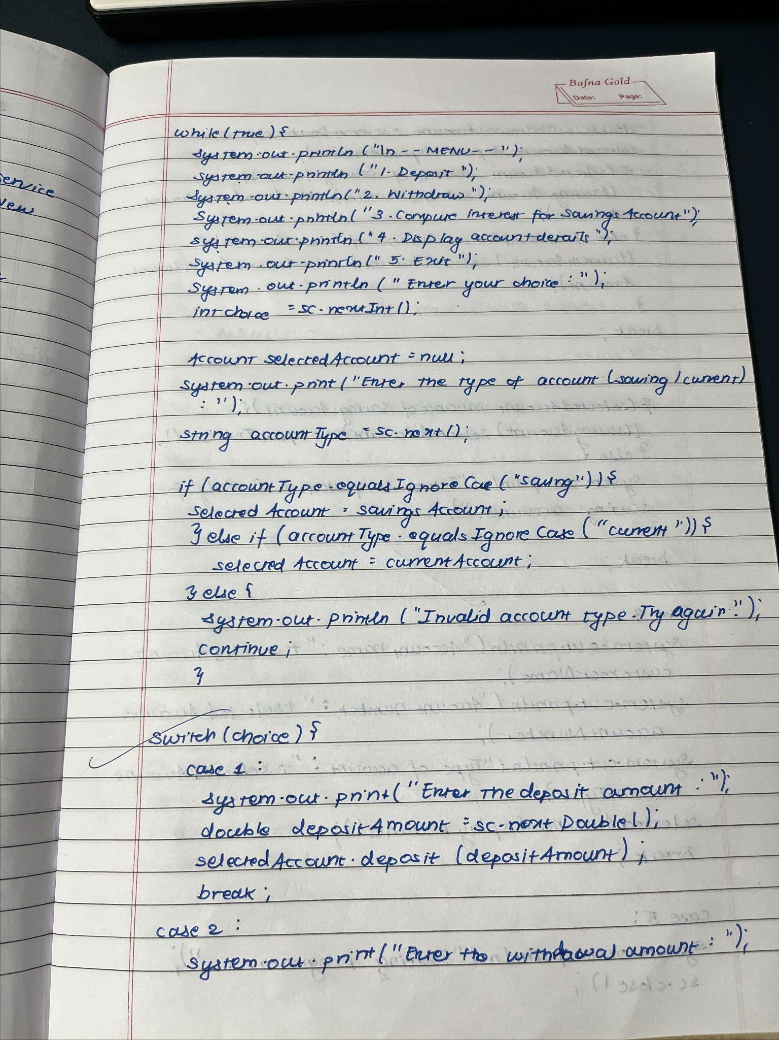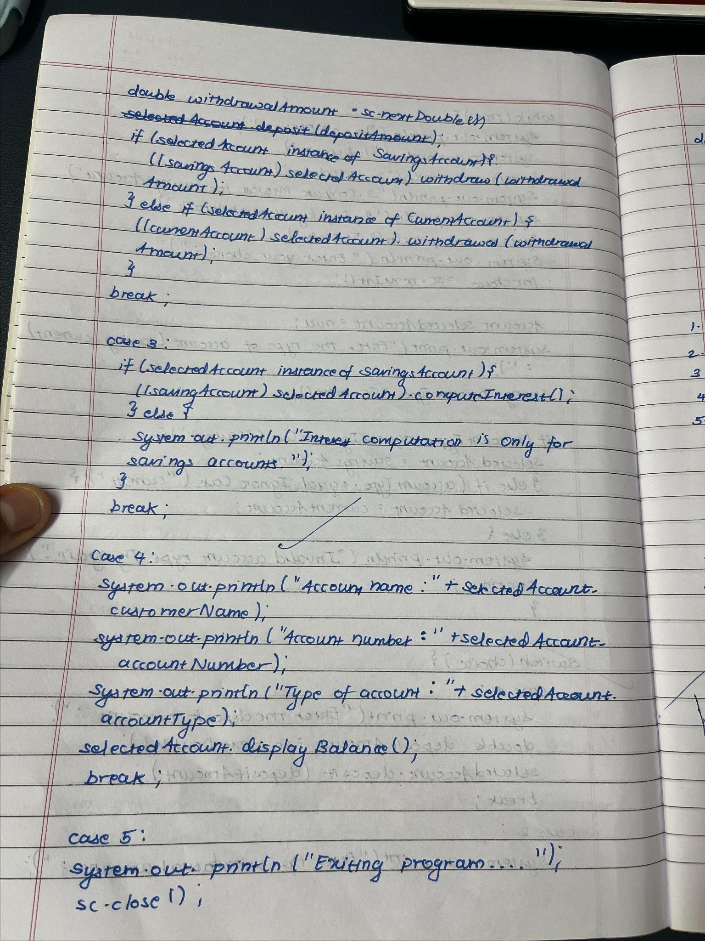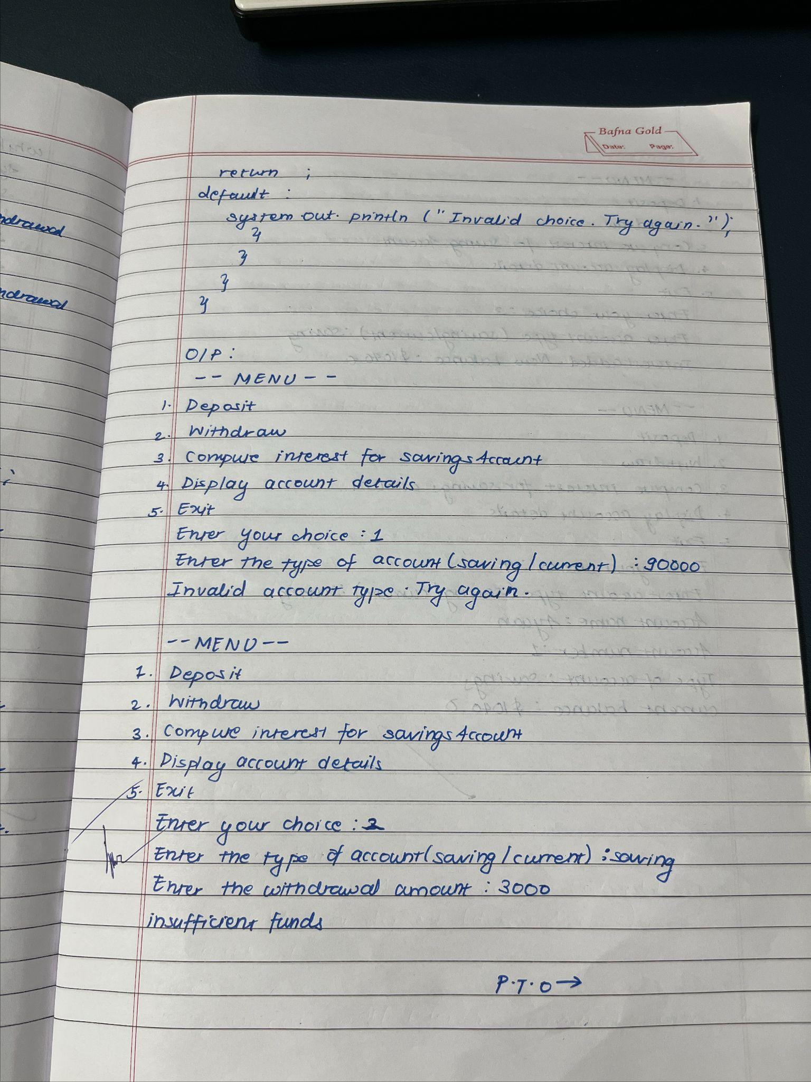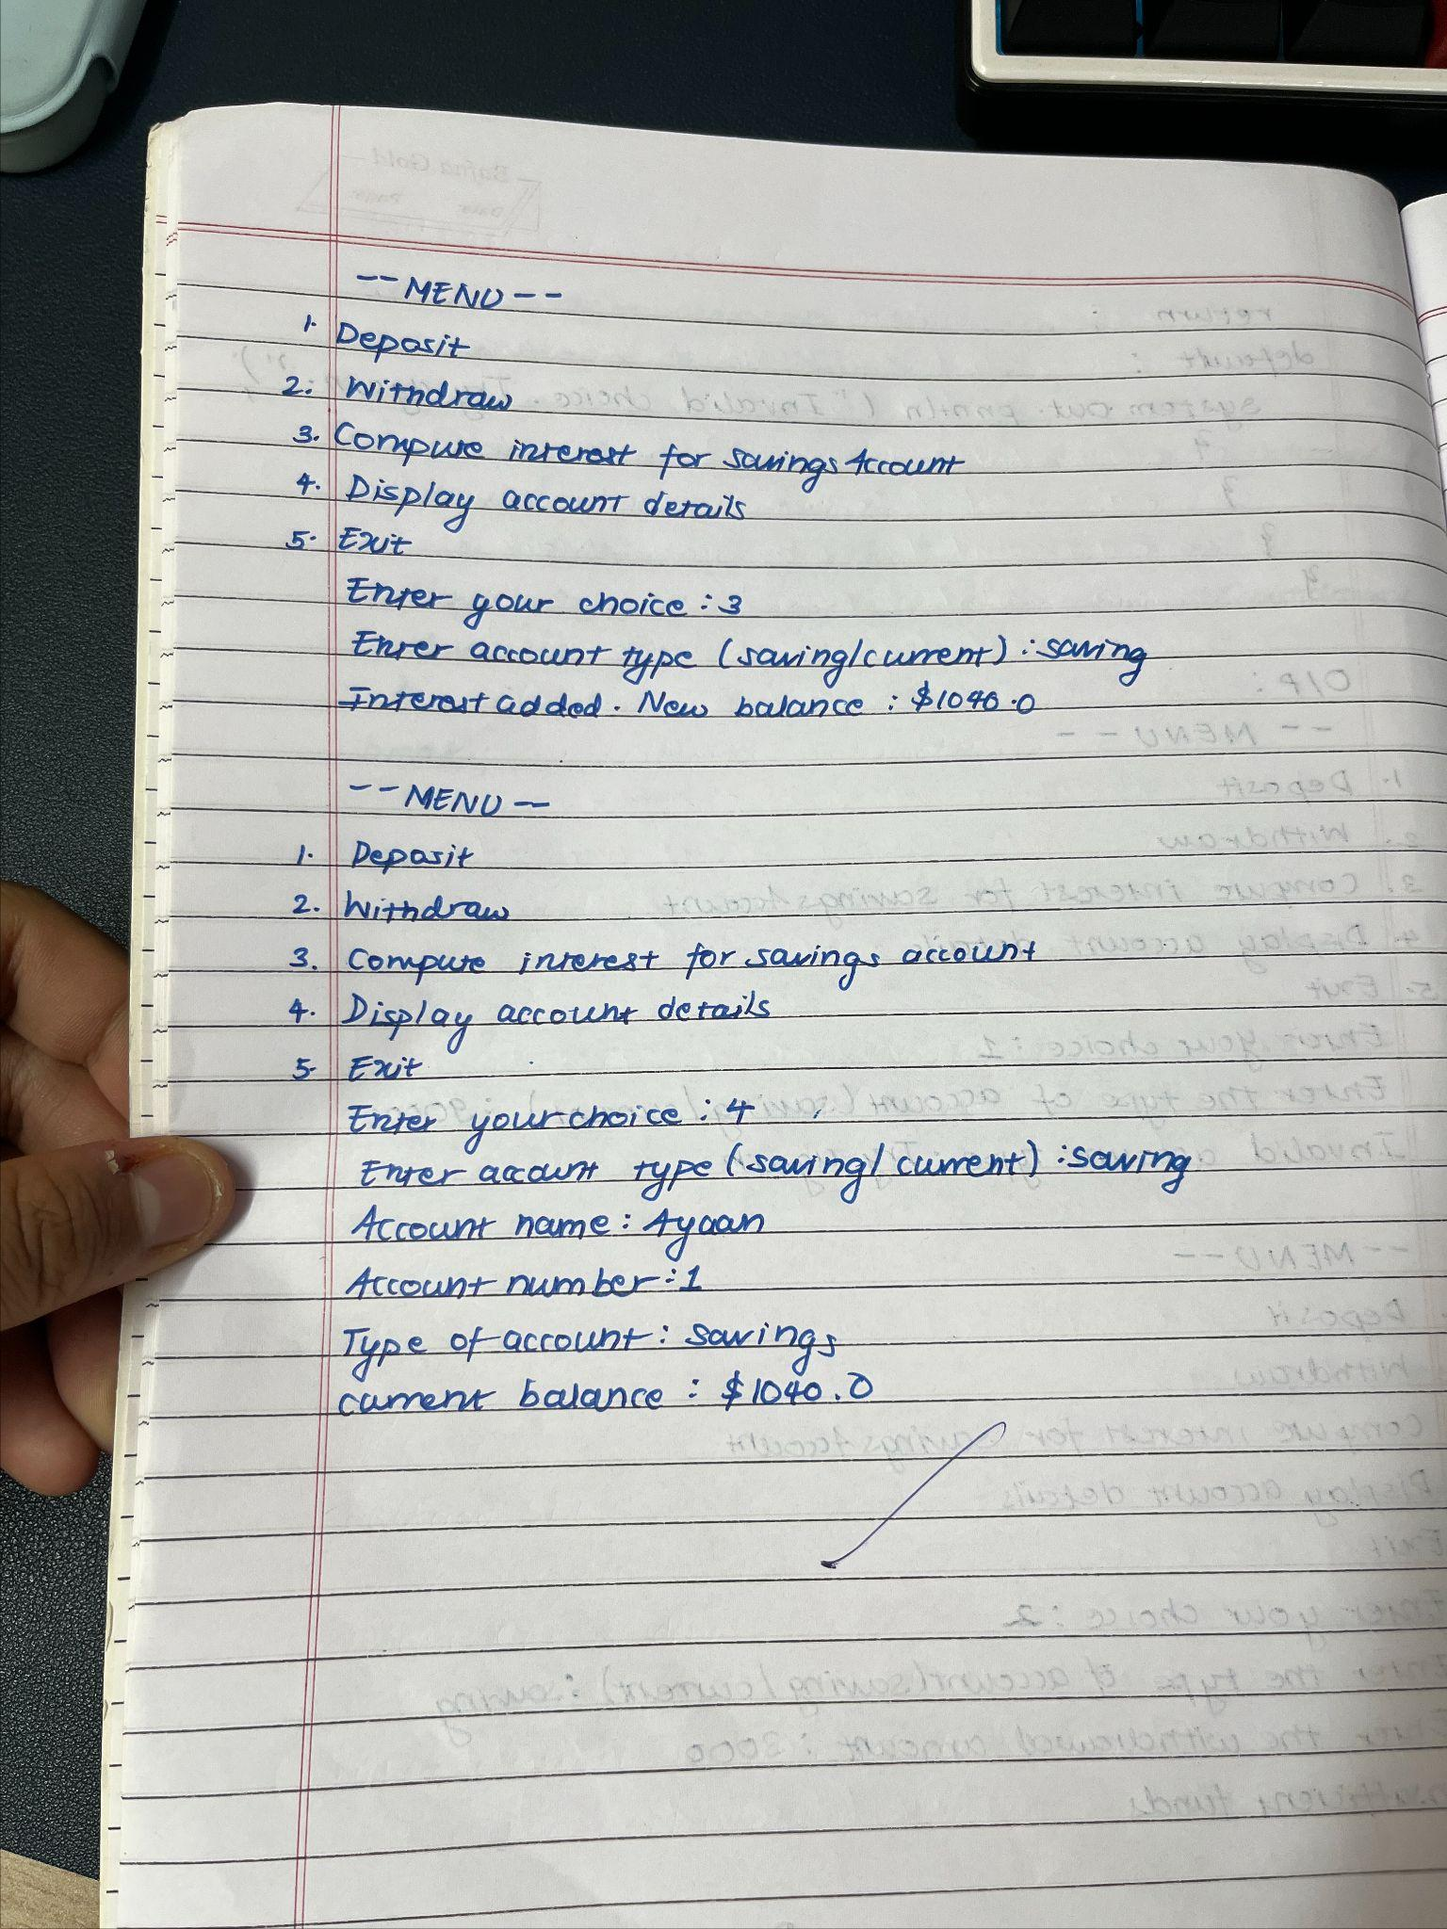

Code :

import java.util.Scanner;

class Account {

String customerName;

int accountNumber;

String accountType;

double balance;

Account(String customerName, int accountNumber, String accountType, double initialBalance) {

this.customerName = customerName;

this.accountNumber = accountNumber;

this.accountType = accountType;

this.balance = initialBalance;

}

void deposit(double amount) {

balance += amount;

System.out.println("Deposit successful. New balance: $" + balance);

}

void displayBalance() {

System.out.println("Current balance: $" + balance);

}

}

class SavingsAccount extends Account {

private static final double INTEREST_RATE = 0.04;

SavingsAccount(String customerName, int accountNumber, double initialBalance) {

super(customerName, accountNumber, "Savings", initialBalance);

}

void computeInterest() {

double interest = balance * INTEREST_RATE;

balance += interest;

System.out.println("Interest added. New balance: $" + balance);

}

void withdraw(double amount) {

if (amount > balance) {

System.out.println("Insufficient funds.");

} else {

balance -= amount;

System.out.println("Withdrawal successful. New balance: $" + balance);

}

}

}

class CurrentAccount extends Account {

private static final double MIN_BALANCE = 500.00;

private static final double SERVICE_CHARGE = 25.00;

CurrentAccount(String customerName, int accountNumber, double initialBalance) {

super(customerName, accountNumber, "Current", initialBalance);

}

void checkMinimumBalance() {

if (balance < MIN_BALANCE) {

balance -= SERVICE_CHARGE;

System.out.println("Below minimum balance. Service charge of $" + SERVICE_CHARGE + " applied. New balance: $" + balance);

} else {

System.out.println("Balance is above the minimum required.");

}

}

void withdraw(double amount) {

if (amount > balance) {

System.out.println("Insufficient funds.");

} else {

balance -= amount;

checkMinimumBalance();

}

}

}

public class Main {

public static void main(String[] args) {

Scanner sc = new Scanner(System.in);

SavingsAccount savingsAccount = new SavingsAccount("Ayaan", 1, 1000.00);

CurrentAccount currentAccount = new CurrentAccount("AyaanStha", 2, 800.00);

while (true) {

System.out.println("\n---MENU---");

System.out.println("1. Deposit");

System.out.println("2. Withdraw");

System.out.println("3. Compute interest for SavingsAccount");

System.out.println("4. Display account details");

System.out.println("5. Exit");

System.out.print("Enter your choice: ");

int choice = sc.nextInt();

Account selectedAccount = null;

System.out.print("Enter the type of account (saving/current): ");

String accountType = sc.next();

if (accountType.equalsIgnoreCase("saving")) {

selectedAccount = savingsAccount;

} else if (accountType.equalsIgnoreCase("current")) {

selectedAccount = currentAccount;

} else {

System.out.println("Invalid account type. Try again.");

continue;

}

switch (choice) {

case 1:

System.out.print("Enter the deposit amount: ");

double depositAmount = sc.nextDouble();

selectedAccount.deposit(depositAmount);

break;

case 2:

System.out.print("Enter the withdrawal amount: ");

double withdrawalAmount = sc.nextDouble();

if (selectedAccount instanceof SavingsAccount) {

((SavingsAccount) selectedAccount).withdraw(withdrawalAmount);

} else if (selectedAccount instanceof CurrentAccount) {

((CurrentAccount) selectedAccount).withdraw(withdrawalAmount);

}

break;

case 3:

if (selectedAccount instanceof SavingsAccount) {

((SavingsAccount) selectedAccount).computeInterest();

} else {

System.out.println("Interest computation is only for savings accounts.");

}

break;

case 4:

System.out.println("Account name: " + selectedAccount.customerName);

System.out.println("Account number: " + selectedAccount.accountNumber);

System.out.println("Type of account: " + selectedAccount.accountType);

selectedAccount.displayBalance();

break;

case 5:

System.out.println("Exiting program...");

sc.close();

return;

default:

System.out.println("Invalid choice. Try again.");

System.out.println("Ayaan Shrestha 1BM23CS056");

}

}

}

}

Output:

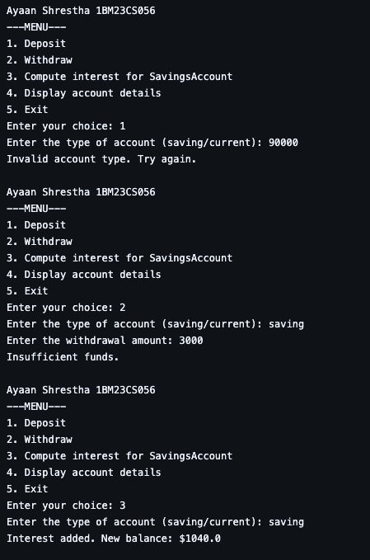

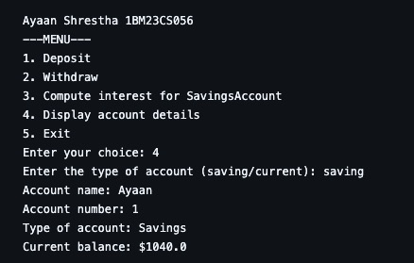

Program No: 6

Implement Packages

Algorithm :

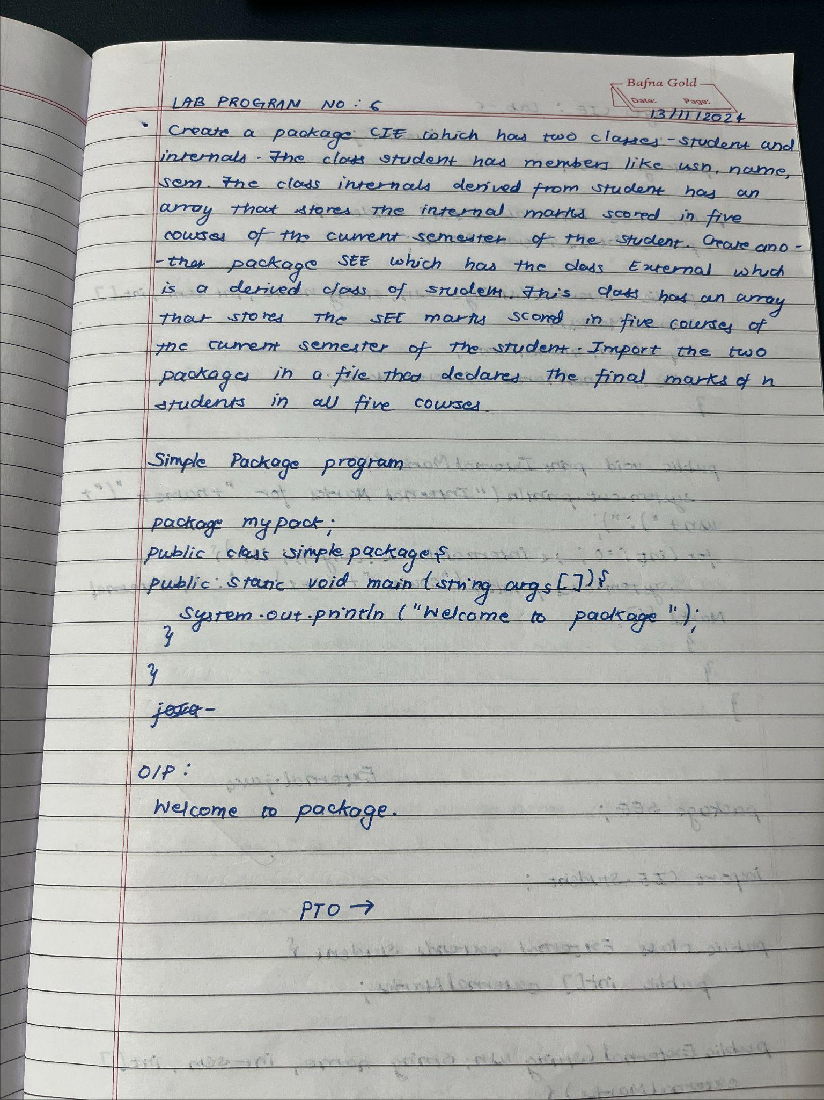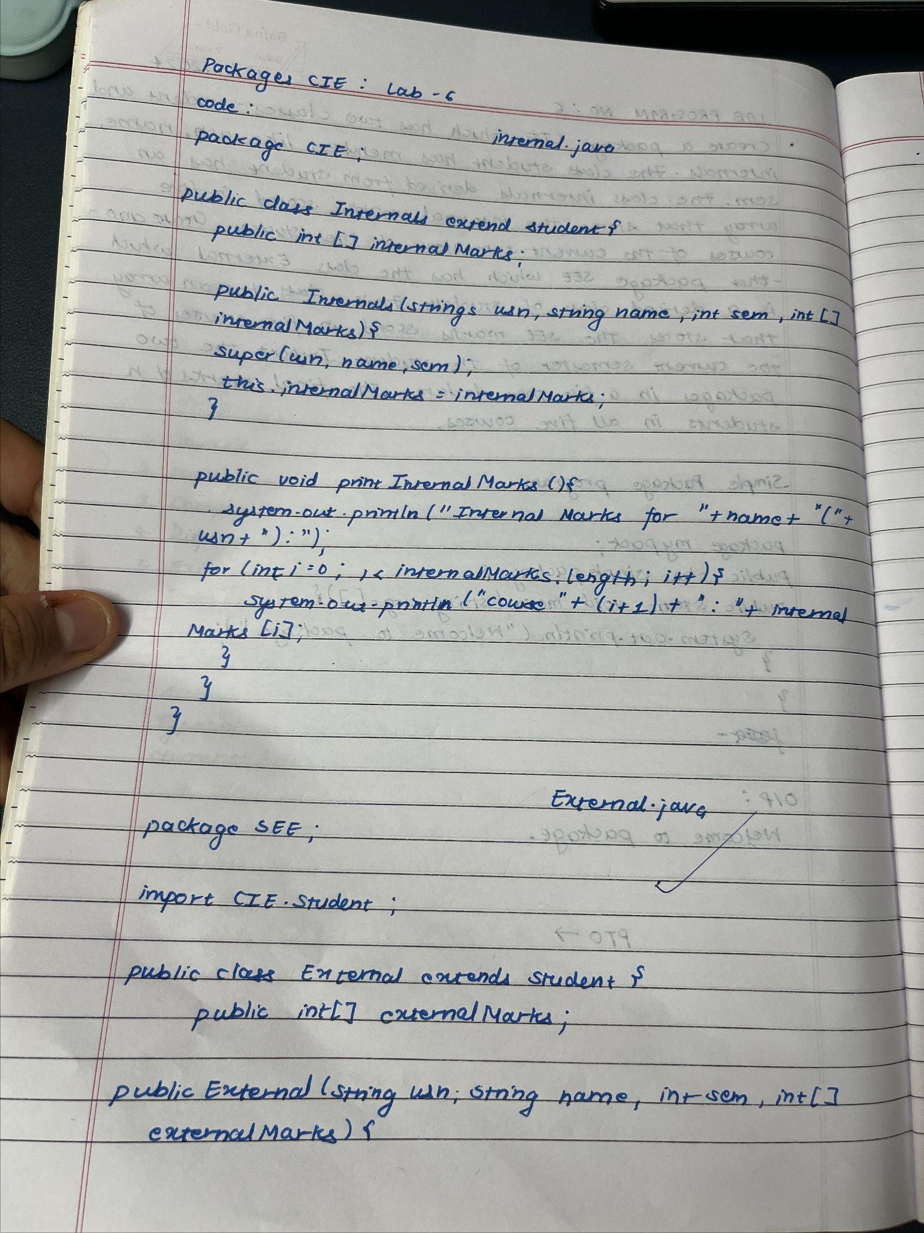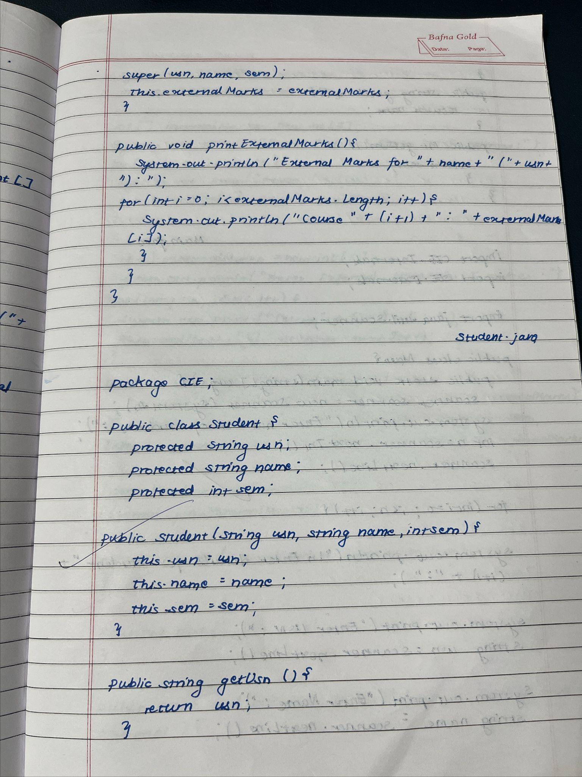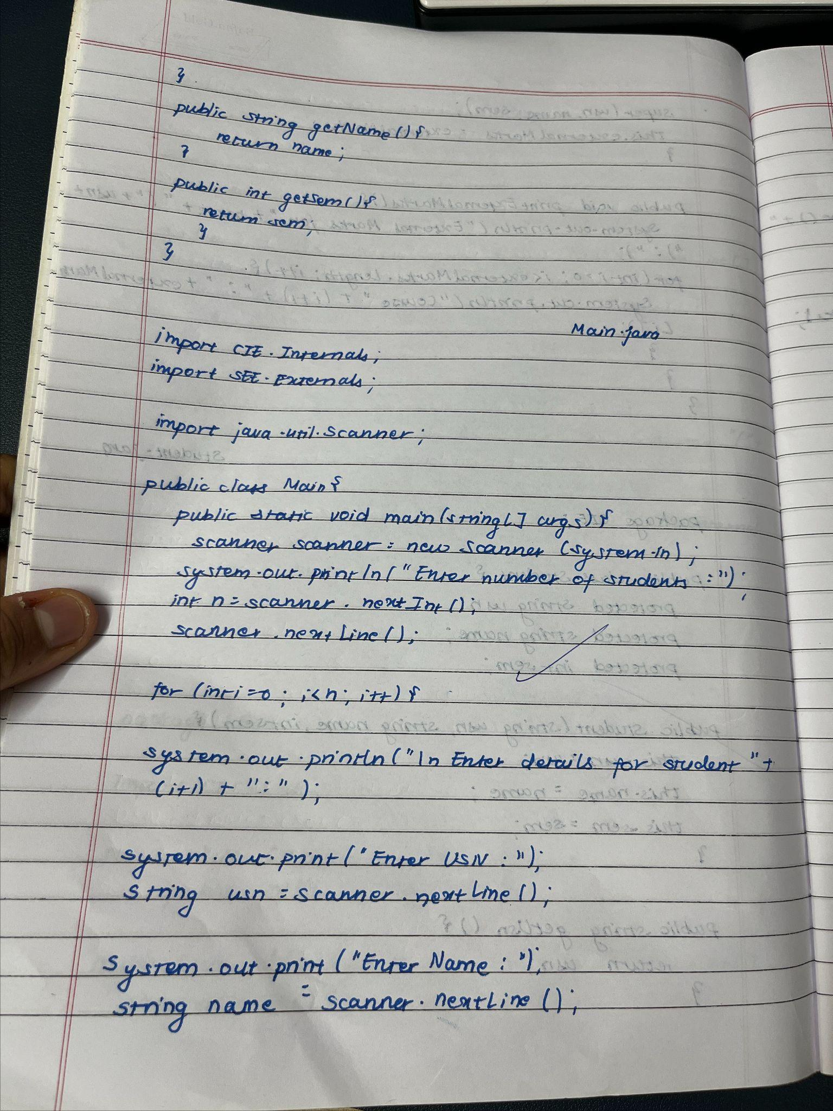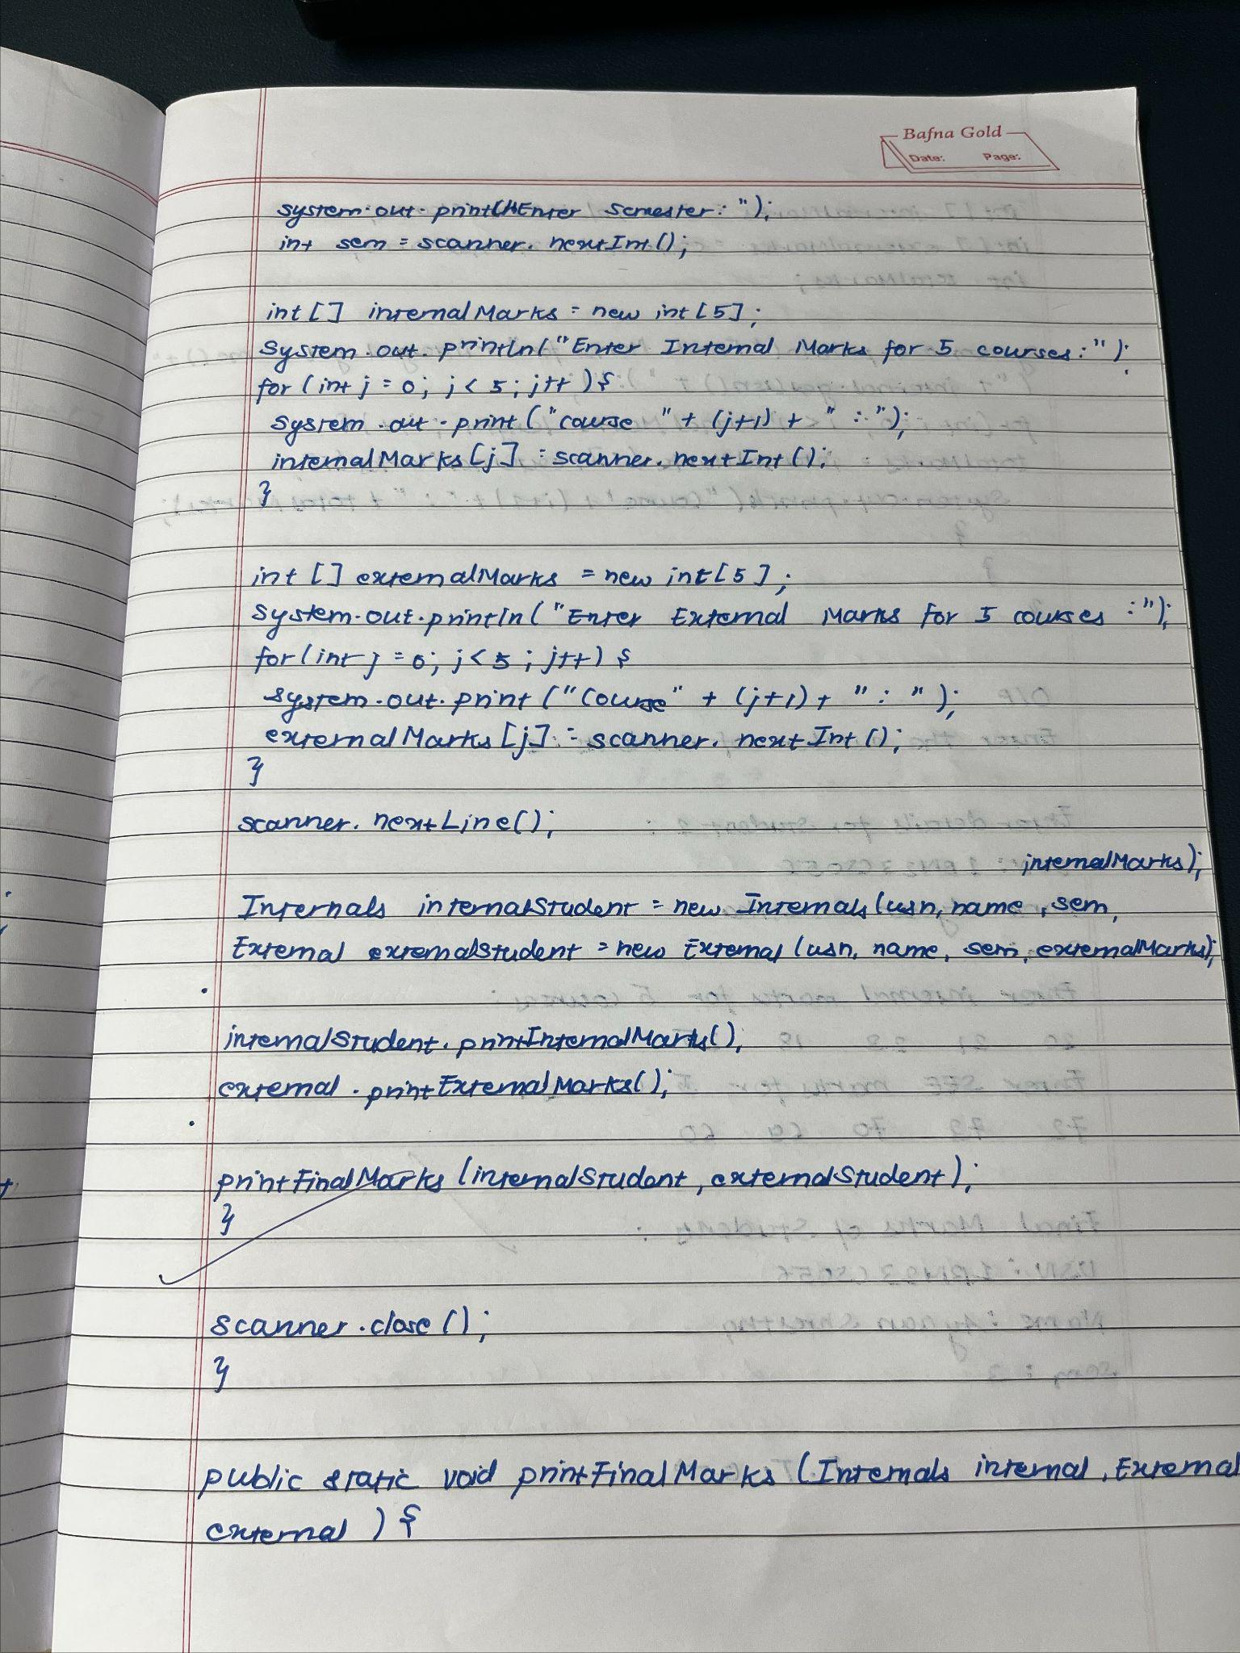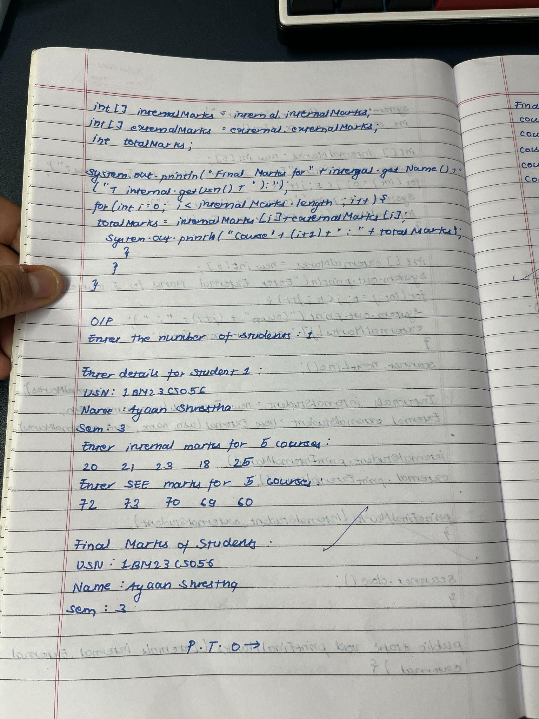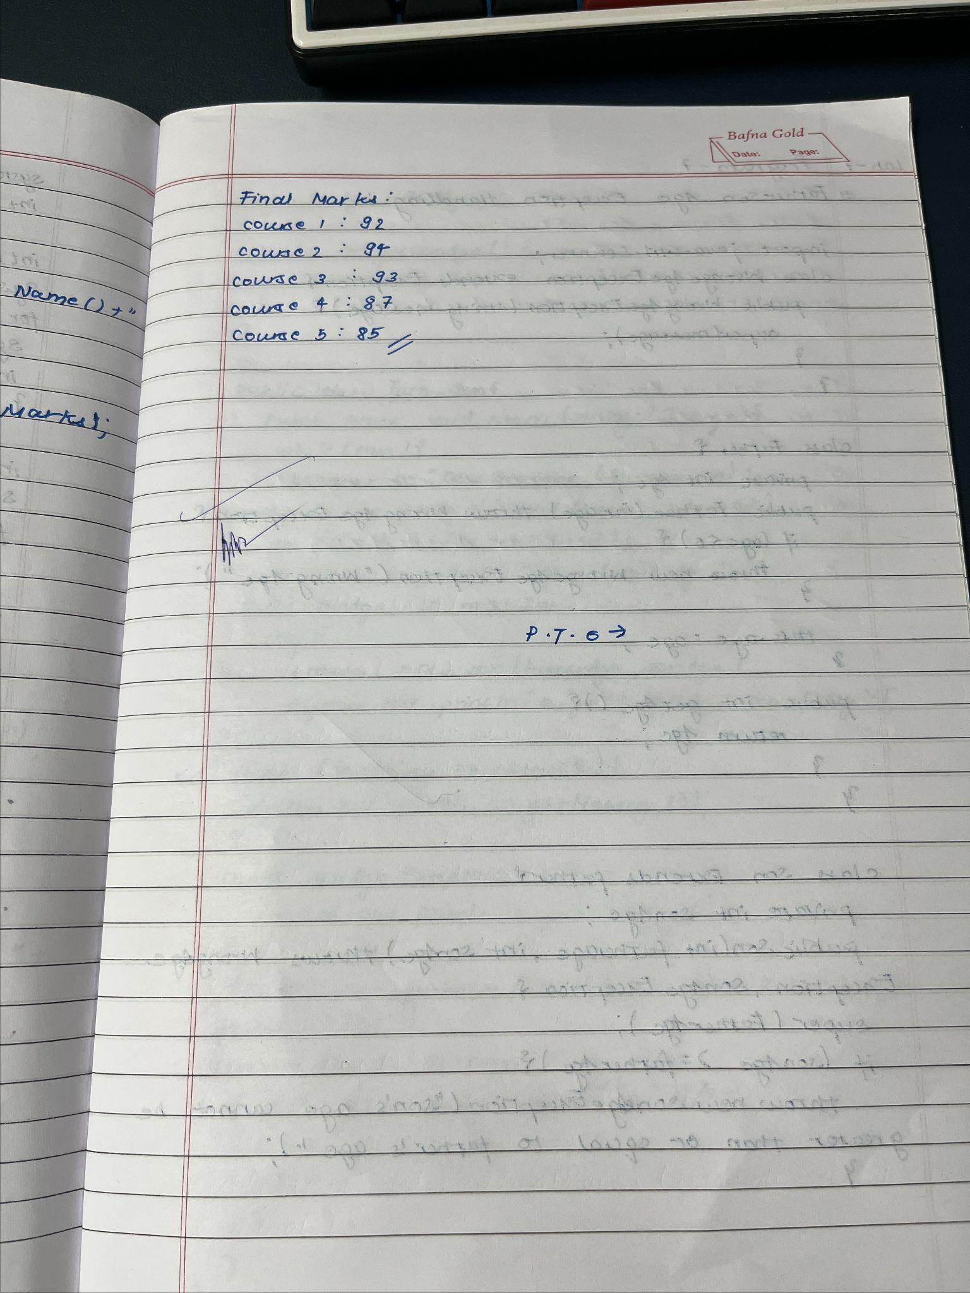

Code :

package SEE;

import CIE.Student;

public class External extends Student {

public int[] externalMarks;

public External(String usn, String name, int sem, int[] externalMarks) {

super(usn, name, sem);

this.externalMarks = externalMarks;

}

public void printExternalMarks() {

System.out.println("External Marks for " + name + " (" + usn + "):");

for (int i = 0; i < externalMarks.length; i++) {

System.out.println("Course " + (i + 1) + ": " + externalMarks[i]);

}

}

}

package CIE;

public class Internals extends Student {

public int[] internalMarks;

public Internals(String usn, String name, int sem, int[] internalMarks) {

super(usn, name, sem);

this.internalMarks = internalMarks;

}

public void printInternalMarks() {

System.out.println("Internal Marks for " + name + " (" + usn + "):");

for (int i = 0; i < internalMarks.length; i++) {

System.out.println("Course " + (i + 1) + ": " + internalMarks[i]);

}

}

}

import CIE.Internals;

import SEE.External;

import java.util.Scanner;

public class Main {

public static void main(String[] args) {

Scanner scanner = new Scanner(System.in);

System.out.print("Enter number of students: ");

int n = scanner.nextInt();

scanner.nextLine();

for (int i = 0; i < n; i++) {

System.out.println("\nEnter details for Student " + (i + 1) + ":");

System.out.print("Enter USN: ");

String usn = scanner.nextLine();

System.out.print("Enter Name: ");

String name = scanner.nextLine();

System.out.print("Enter Semester: ");

int sem = scanner.nextInt();

int[] internalMarks = new int[5];

System.out.println("Enter Internal Marks for 5 Courses:");

for (int j = 0; j < 5; j++) {

System.out.print("Course " + (j + 1) + ": ");

internalMarks[j] = scanner.nextInt();

}

int[] externalMarks = new int[5];

System.out.println("Enter External Marks for 5 Courses:");

for (int j = 0; j < 5; j++) {

System.out.print("Course " + (j + 1) + ": ");

externalMarks[j] = scanner.nextInt();

}

scanner.nextLine();

Internals internalStudent = new Internals(usn, name, sem, internalMarks);

External externalStudent = new External(usn, name, sem, externalMarks);

internalStudent.printInternalMarks();

externalStudent.printExternalMarks();

printFinalMarks(internalStudent, externalStudent);

}

scanner.close();

}

public static void printFinalMarks(Internals internal, External external) {

int[] internalMarks = internal.internalMarks;

int[] externalMarks = external.externalMarks;

int totalMarks;

System.out.println("Final Marks for " + internal.getName() + " (" + internal.getUsn() + "):");

for (int i = 0; i < internalMarks.length; i++) {

totalMarks = internalMarks[i] + externalMarks[i];

System.out.println("Course " + (i + 1) + ": " + totalMarks);

}

}

}

package CIE;

public class Student {

protected String usn;

protected String name;

protected int sem;

public Student(String usn, String name, int sem) {

this.usn = usn;

this.name = name;

this.sem = sem;

}

// Getter methods

public String getUsn() {

return usn;

}

public String getName() {

return name;

}

public int getSem() {

return sem;

}

}

Output :

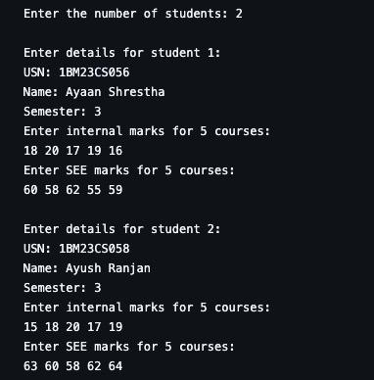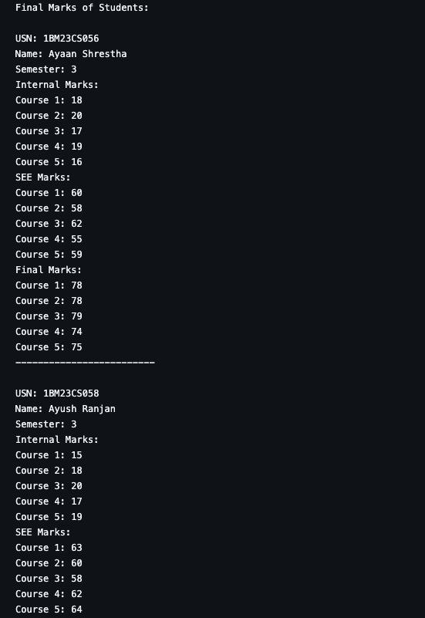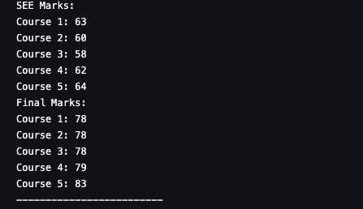

Program No : 7

Implement Exception Handling

Algorithm :

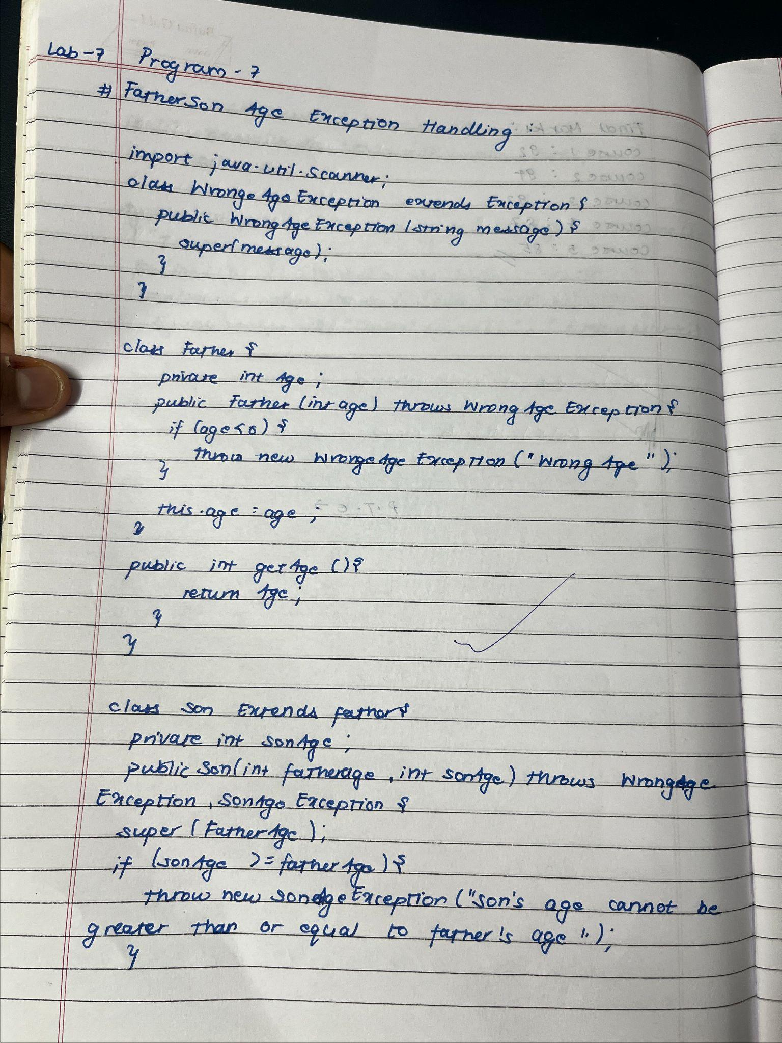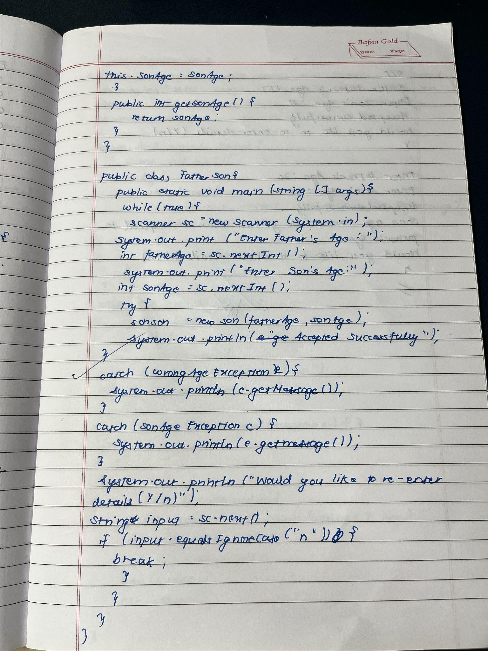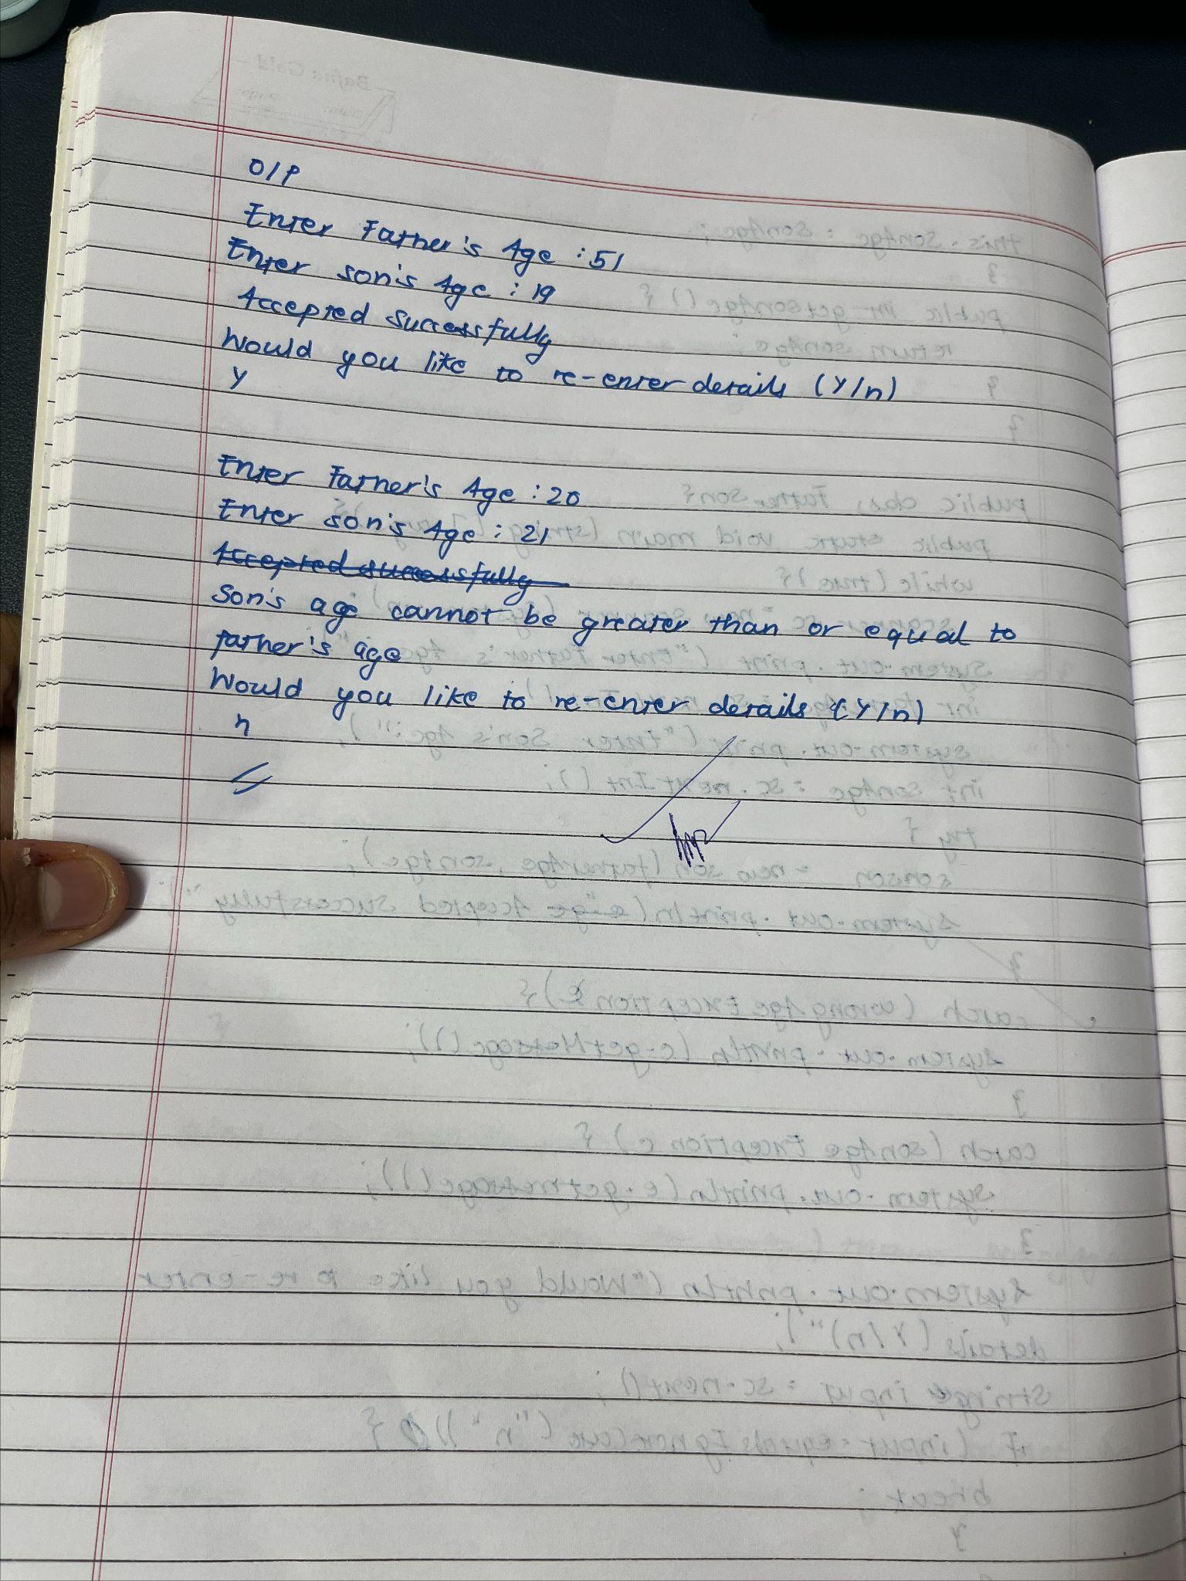

Code :

import java.util.Scanner;

class WrongAgeException extends Exception {

public WrongAgeException(String message) {

super(message);

}

}

class SonAgeException extends Exception {

public SonAgeException(String message) {

super(message);

}

}

class Father {

private int age;

public Father(int age) throws WrongAgeException {

if (age < 0) {

throw new WrongAgeException("Wrong age");

}

this.age = age;

}

public int getAge() {

return age;

}

}

class Son extends Father {

private int sonAge;

public Son(int fatherAge, int sonAge) throws WrongAgeException, SonAgeException {

super(fatherAge);

if (sonAge >= fatherAge) {

throw new SonAgeException("Son's age cannot be greater than or equal to father's age");

}

this.sonAge = sonAge;

}

public int getSonAge() {

return sonAge;

}

}

public class FatherSon{

public static void main(String[] args) {

while(true){

Scanner sc = new Scanner(System.in);

System.out.print("Enter Father's Age: ");

int fatherAge = sc.nextInt();

System.out.print("Enter Son's Age: ");

int sonAge = sc.nextInt();

try {

Son son = new Son(fatherAge, sonAge);

System.out.println("Accepted Succesfully");

}

catch (WrongAgeException e) {

System.out.println(e.getMessage());

}

catch (SonAgeException e) {

System.out.println(e.getMessage());

}

System.out.println("Would you like to re-enter details (Y/n)");

String input = sc.next();

if (input.equalsIgnoreCase("n")) {

break;

}

}

}

}

Output:

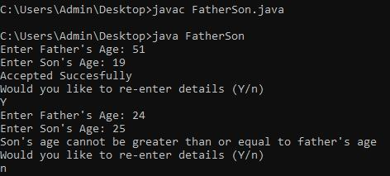

Program No : 8

Multithreading, Creating Threads in Java

Algorithm :

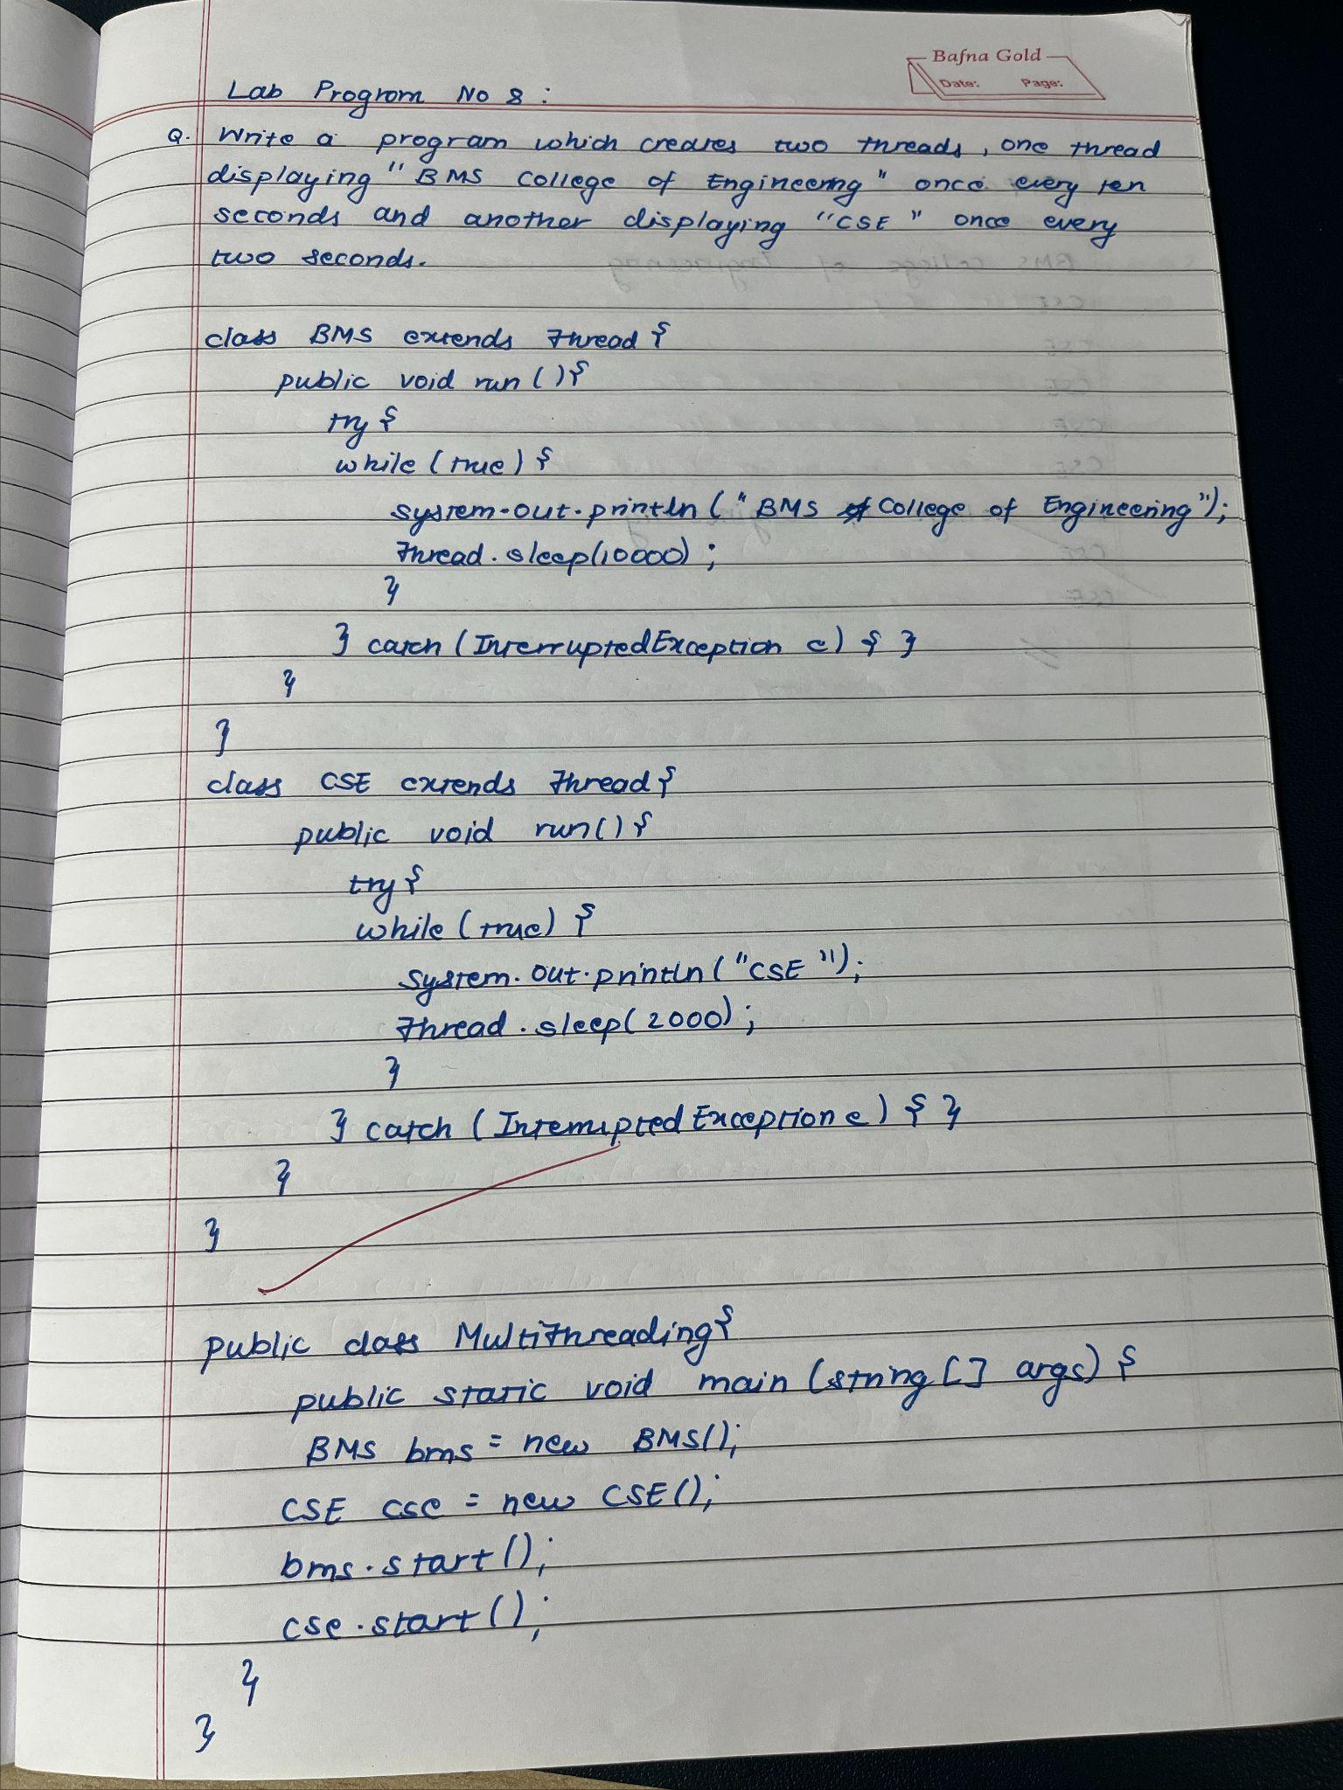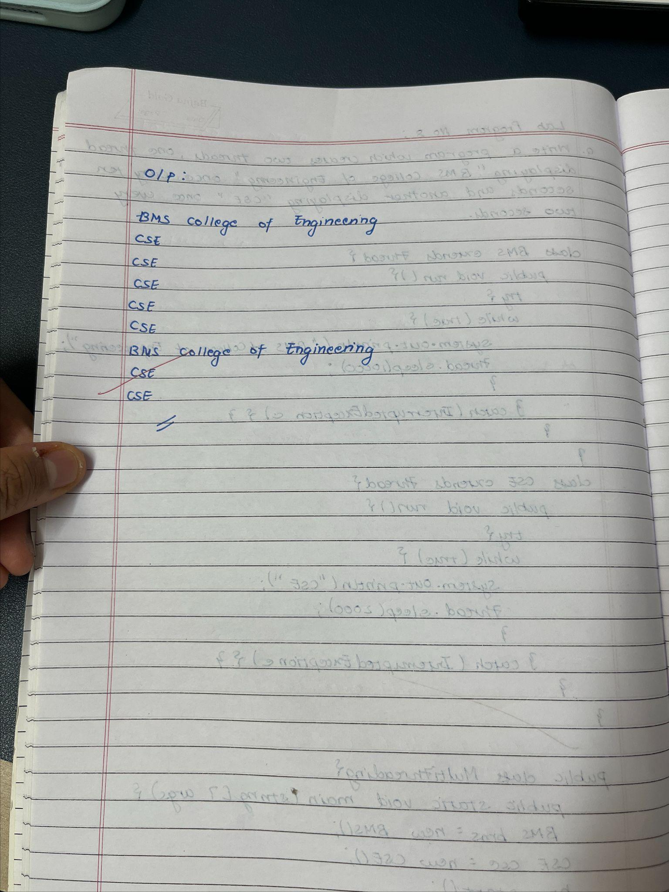

Code :

class BMS extends Thread {

public void run() {

try {

while (true) {

System.out.println("BMS College of Engineering");

Thread.sleep(10000); // Sleep for 10 seconds

}

}catch (InterruptedException e) {}

}

}

class CSE extends Thread {

public void run() {

try {

while (true) {

System.out.println("CSE");

Thread.sleep(2000); // Sleep for 2 seconds

}

}catch (InterruptedException e) {}

}

}

public class Multithreading{

public static void main(String[] args) {

BMS bms = new BMS();

CSE cse = new CSE();

bms.start();

cse.start();

}

}

Output:

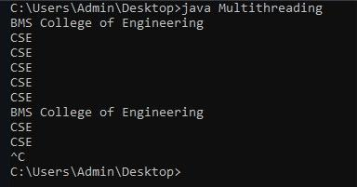

Program No : 9

Interface to Perform Integer Division

Algorithm :

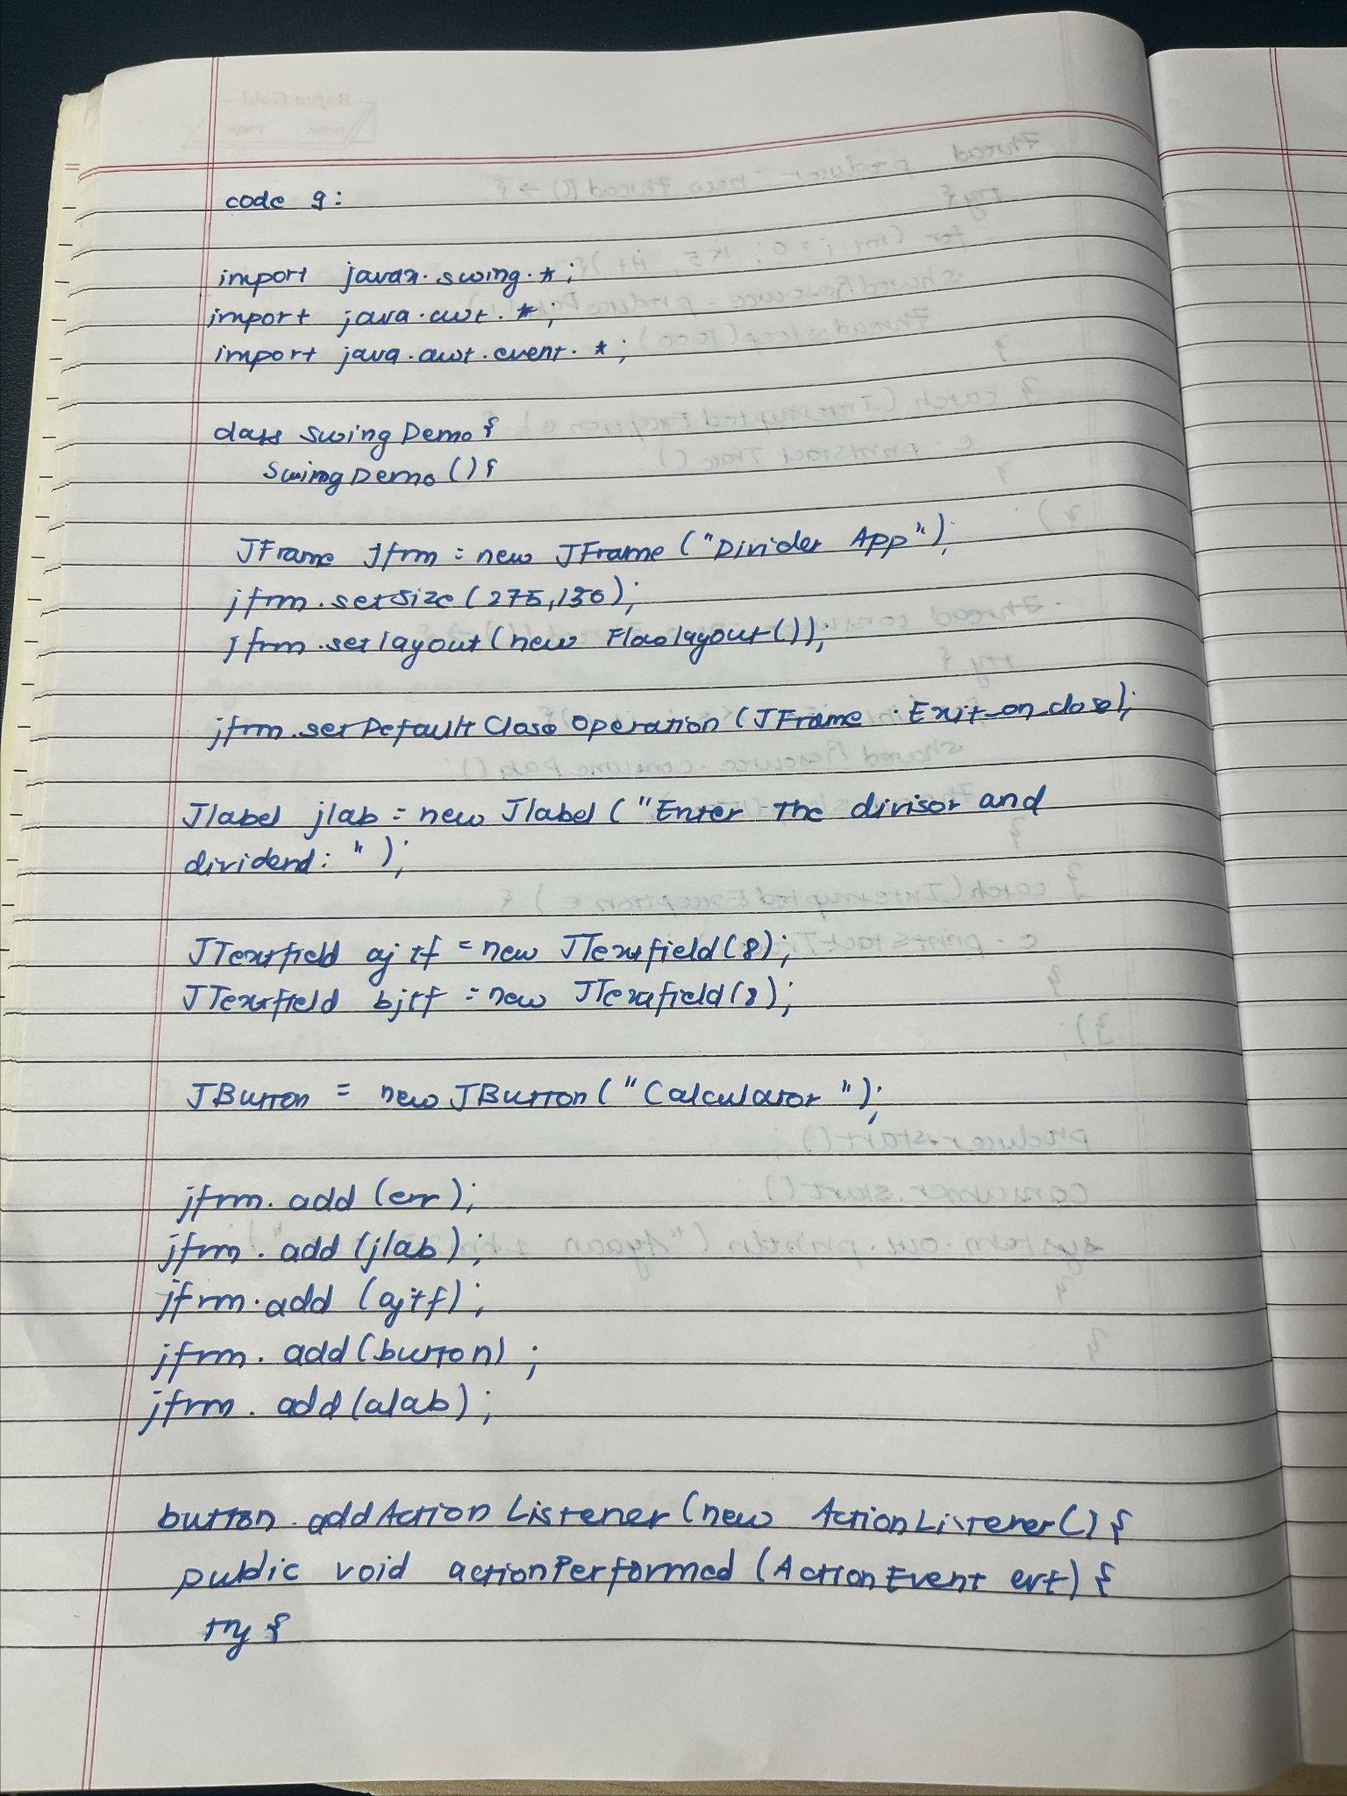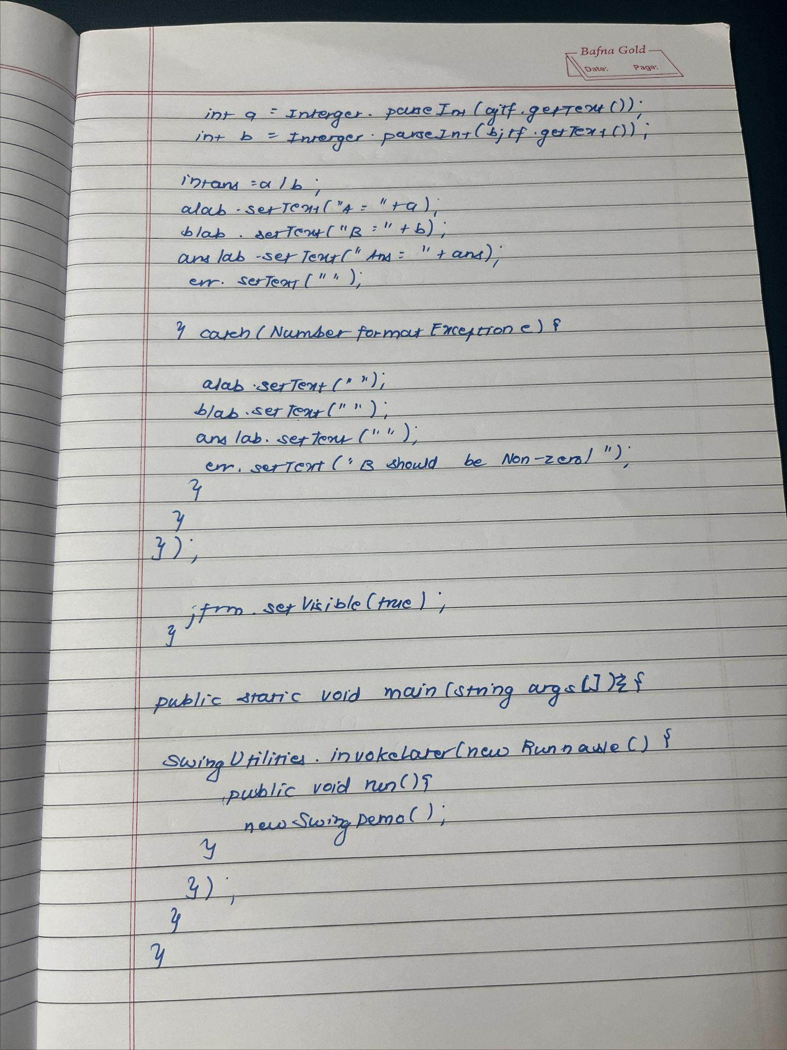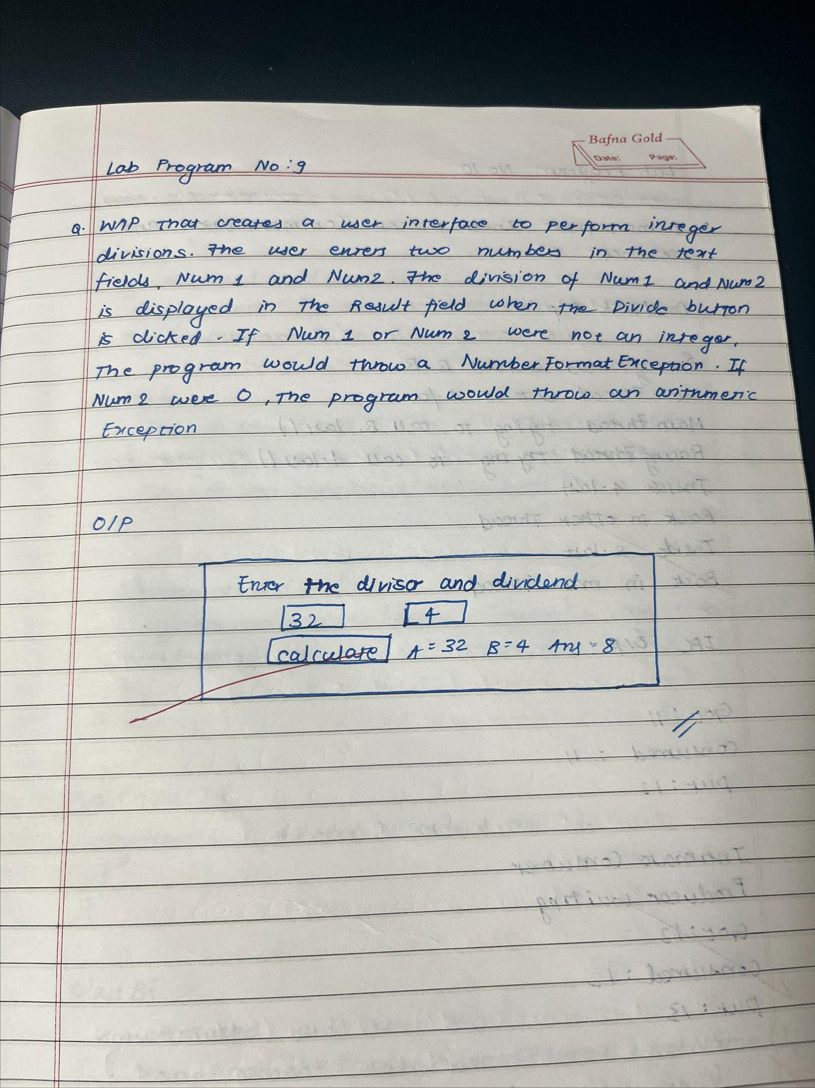

Code :

import javax.swing.*;

import java.awt.*;

import java.awt.event.*;

class SwingDemo {

SwingDemo() {

JFrame jfrm = new JFrame("Divider App");

jfrm.setSize(275, 150);

jfrm.setLayout(new FlowLayout());

jfrm.setDefaultCloseOperation(JFrame.EXIT_ON_CLOSE);

JLabel jlab = new JLabel("Enter the divisor and dividend:");

JTextField ajtf = new JTextField(8);

JTextField bjtf = new JTextField(8);

JButton button = new JButton("Calculate");

JLabel err = new JLabel();

JLabel alab = new JLabel();

JLabel blab = new JLabel();

JLabel anslab = new JLabel();

jfrm.add(err);

jfrm.add(jlab);

jfrm.add(ajtf);

jfrm.add(bjtf);

jfrm.add(button);

jfrm.add(alab);

jfrm.add(blab);

jfrm.add(anslab);

button.addActionListener(new ActionListener() {

public void actionPerformed(ActionEvent evt) {

try {

int a = Integer.parseInt(ajtf.getText());

int b = Integer.parseInt(bjtf.getText());

int ans = a / b;

alab.setText("A = " + a);

blab.setText("B = " + b);

anslab.setText("Ans = " + ans);

err.setText("");

} catch (NumberFormatException e) {

alab.setText("");

blab.setText("");

anslab.setText("");

err.setText("Enter Only Integers!");

} catch (ArithmeticException e) {

alab.setText("");

blab.setText("");

anslab.setText("");

err.setText("B should be NON-zero!");

}

}

});

jfrm.setVisible(true);

}

public static void main(String args[]) {

SwingUtilities.invokeLater(new Runnable() {

public void run() {

new SwingDemo();

}

});

}

}

Output :

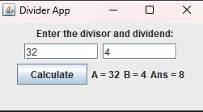

Program 10.1

Implement Deadlock

Algorithm :

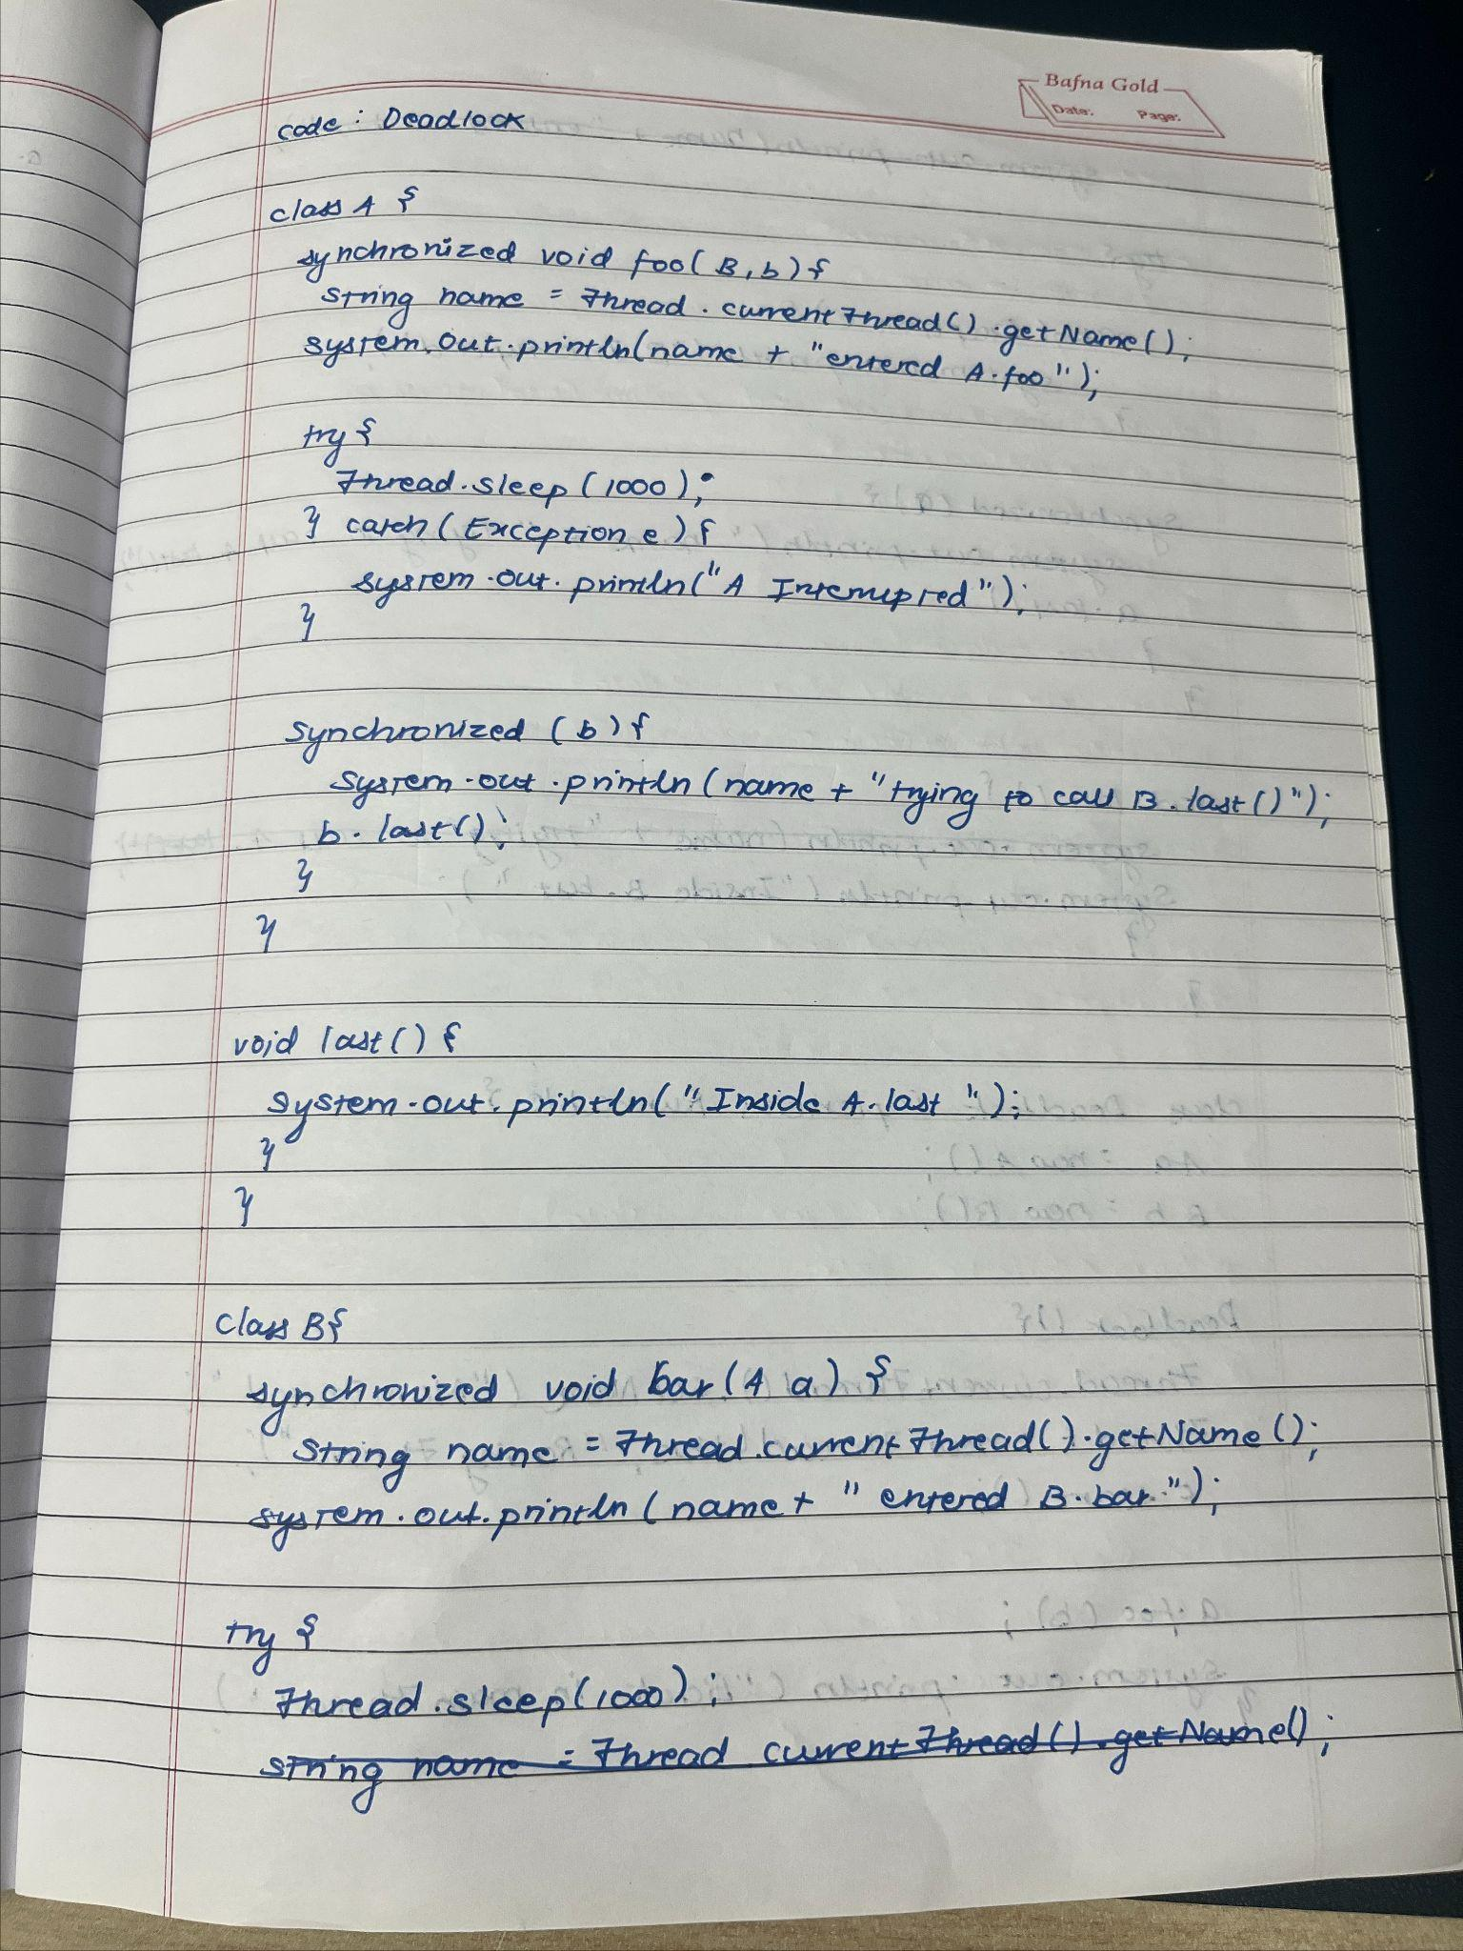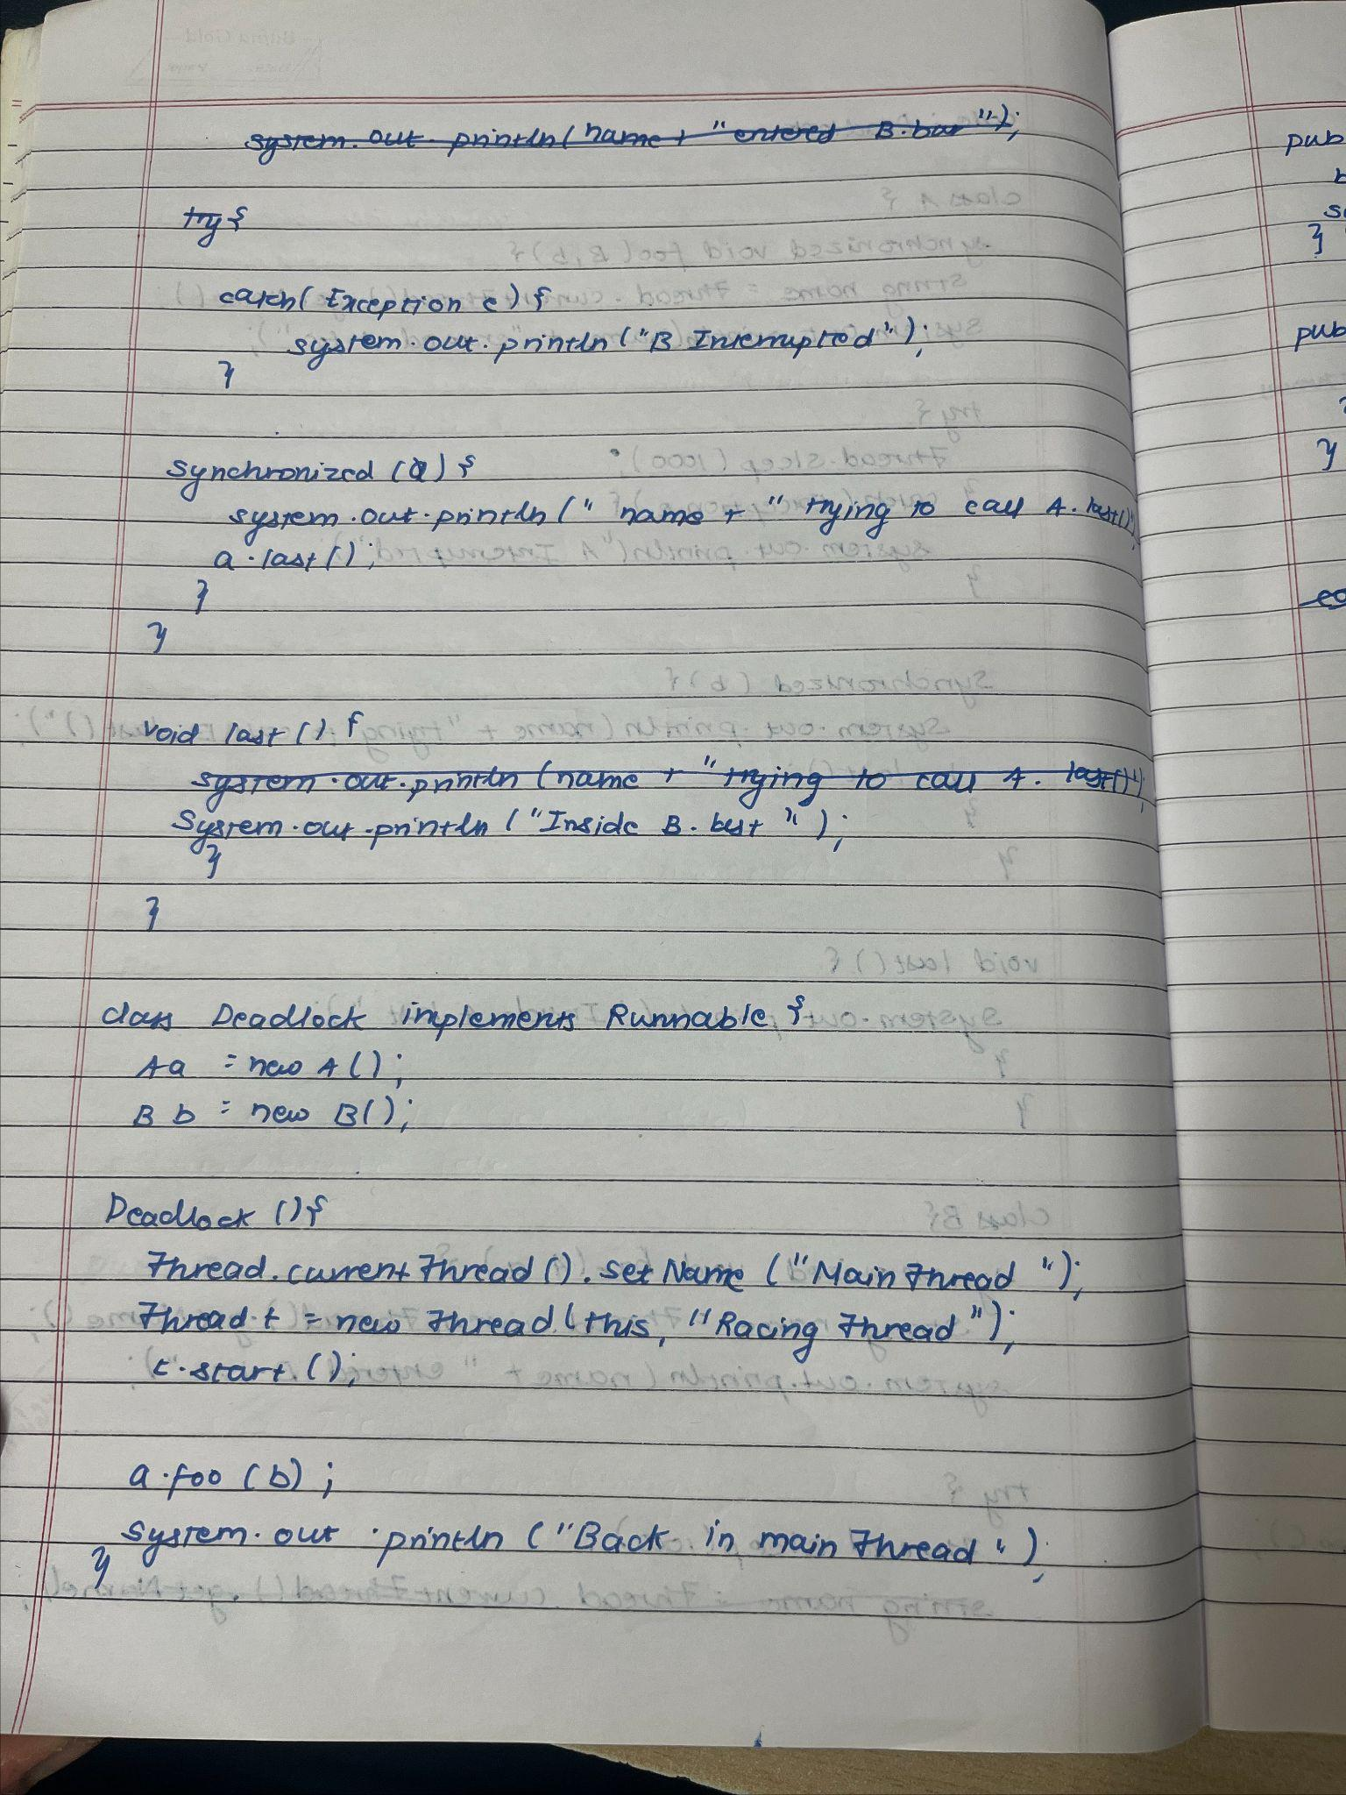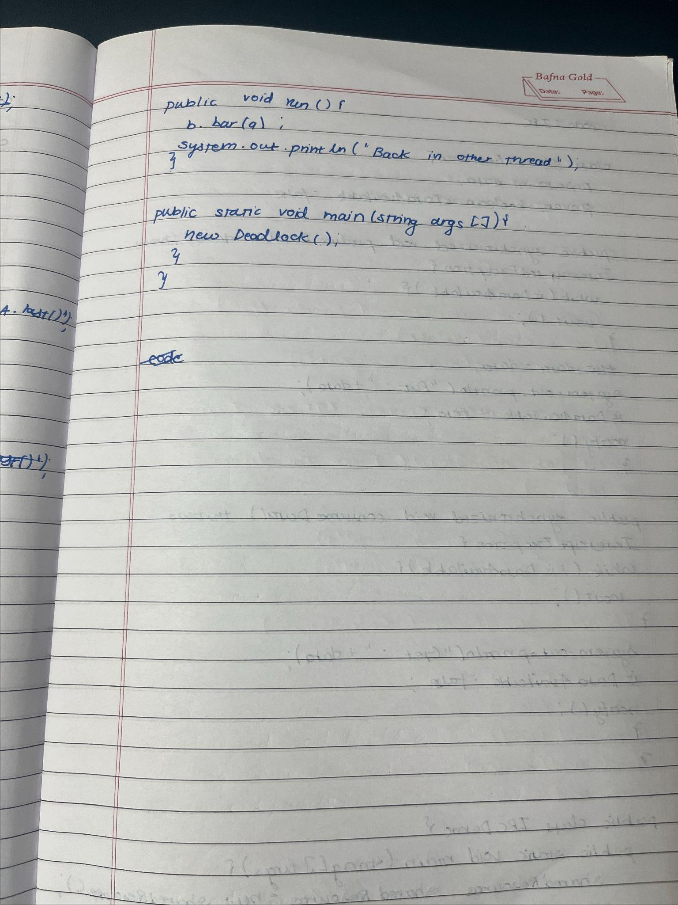

Code :

class A {

synchronized void foo(B b) {

String name = Thread.currentThread().getName();

System.out.println(name + " entered A.foo");

try {

Thread.sleep(1000);

} catch (Exception e) {

System.out.println("A Interrupted");

}

synchronized (b) {

System.out.println(name + " trying to call B.last()");

b.last();

}

}

void last() {

System.out.println("Inside A.last");

}

}

class B {

synchronized void bar(A a) {

String name = Thread.currentThread().getName();

System.out.println(name + " entered B.bar");

try {

Thread.sleep(1000);

} catch (Exception e) {

System.out.println("B Interrupted");

}

synchronized (a) {

System.out.println(name + " trying to call A.last()");

a.last();

}

}

void last() {

System.out.println("Inside B.last");

}

}

class Deadlock implements Runnable {

A a = new A();

B b = new B();

Deadlock() {

Thread.currentThread().setName("MainThread");

Thread t = new Thread(this, "RacingThread");

t.start();

a.foo(b);

System.out.println("Back in main thread");

}

public void run() {

b.bar(a);

System.out.println("Back in other thread");

}

public static void main(String args[]) {

new Deadlock();

}

}

Output:

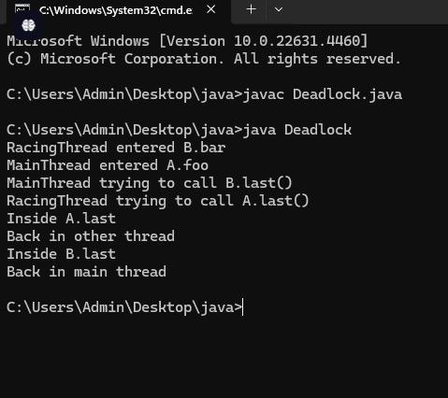

Program 10.2 :

Implement Inter-process Communication

Algorithm :

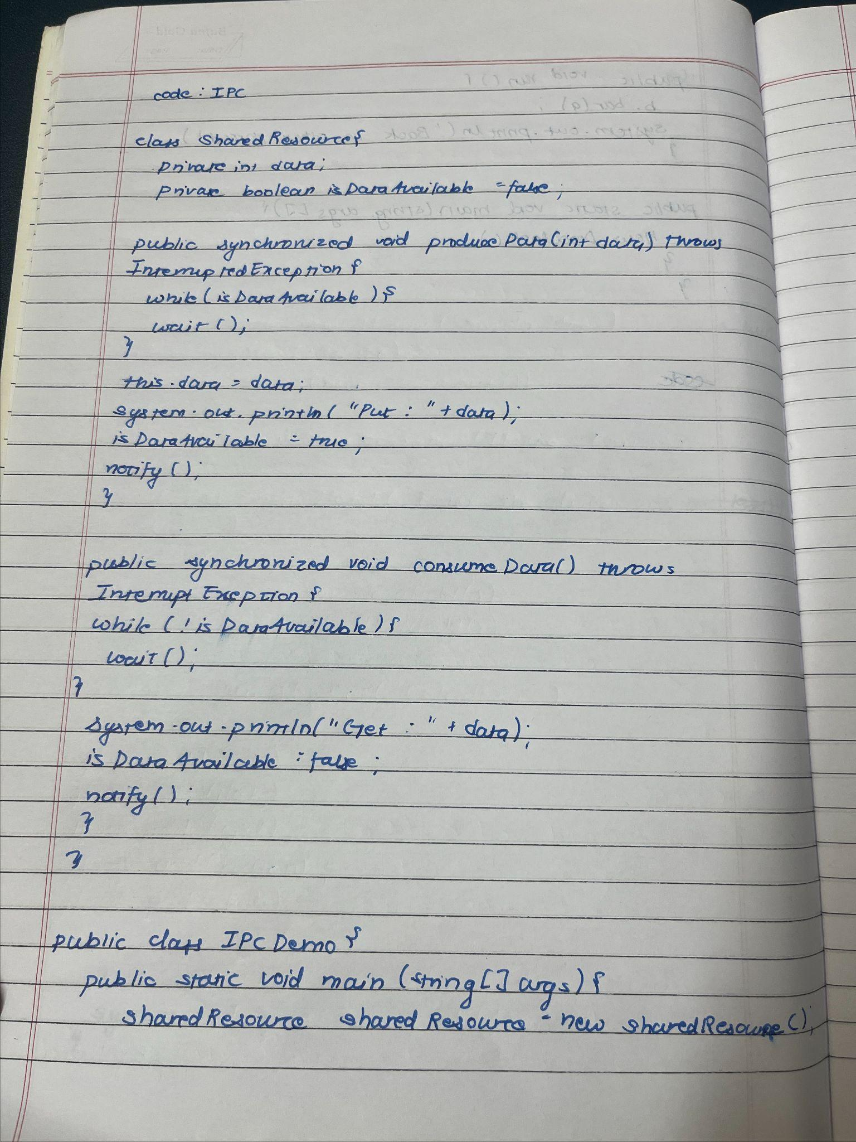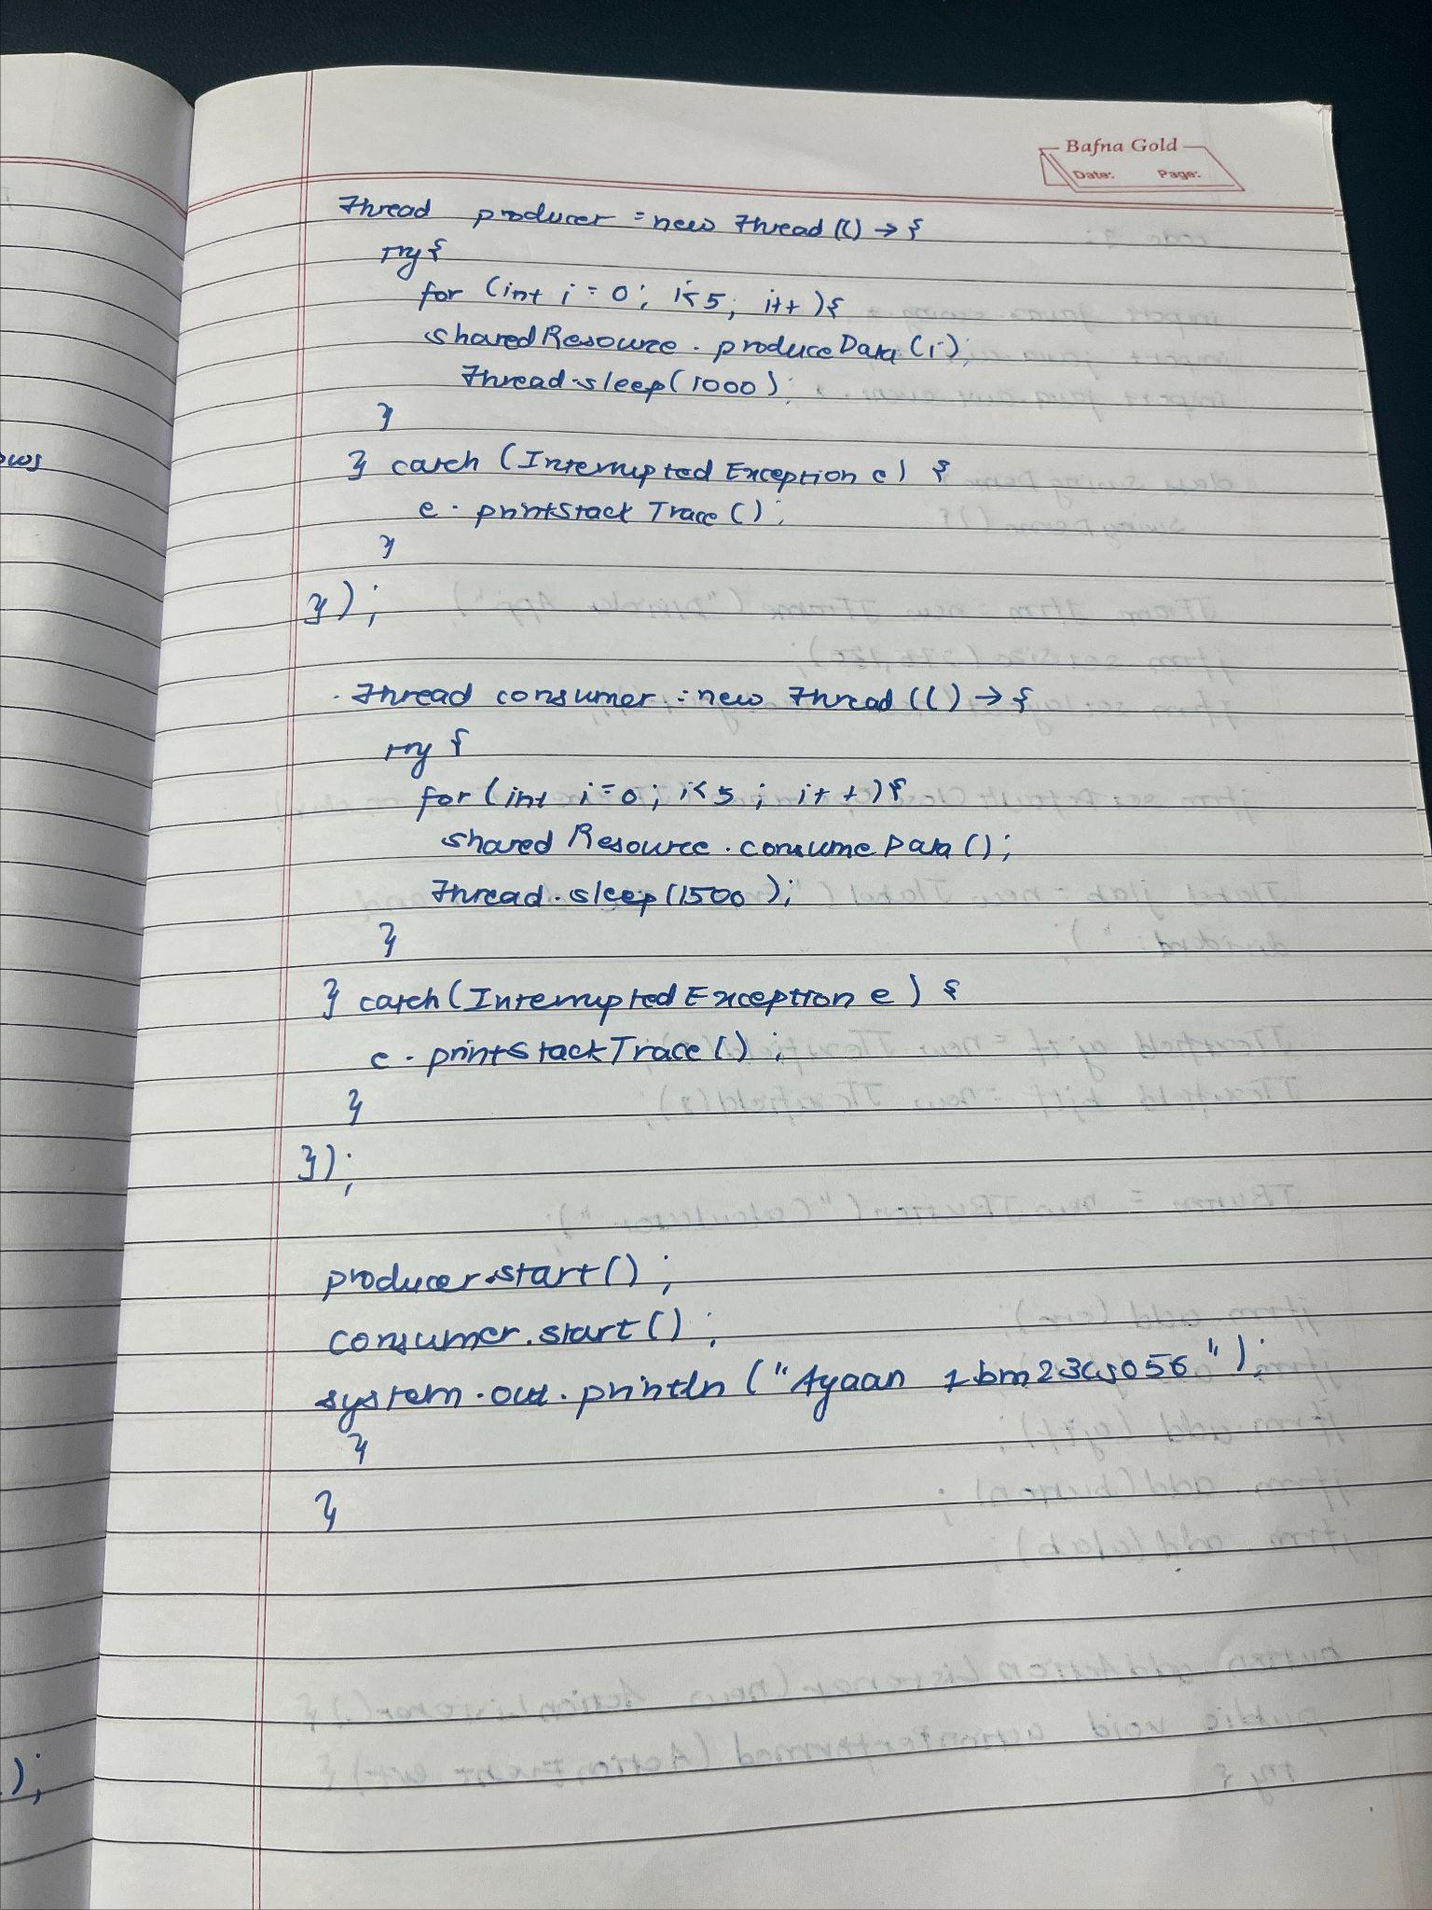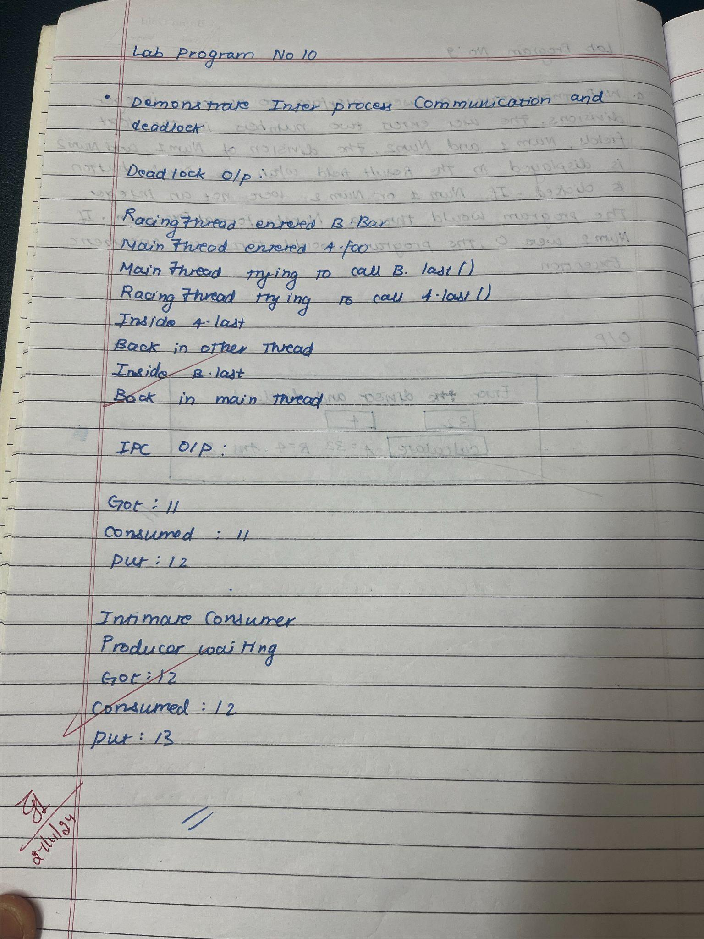

Code :

class SharedResource {

private int data;

private boolean isDataAvailable = false;

public synchronized void produceData(int data) throws InterruptedException {

while (isDataAvailable) {

wait();

}

this.data = data;

System.out.println("Put: " + data);

isDataAvailable = true;

notify();

}

public synchronized void consumeData() throws InterruptedException {

while (!isDataAvailable) {

wait();

}

System.out.println("Get: " + data);

isDataAvailable = false;

notify();

}

}

public class IPCDemo {

public static void main(String[] args) {

SharedResource sharedResource = new SharedResource();

Thread producer = new Thread(() -> {

try {

for (int i = 0; i < 5; i++) {

sharedResource.produceData(i);

Thread.sleep(1000);

}

} catch (InterruptedException e) {

e.printStackTrace();

}

});

Thread consumer = new Thread(() -> {

try {

for (int i = 0; i < 5; i++) {

sharedResource.consumeData();

Thread.sleep(1500);

}

} catch (InterruptedException e) {

e.printStackTrace();

}

});

producer.start();

consumer.start();

System.out.println("Ayaan 1bm23cs056");

}

}

OutPut:

